**SMART GOAL: Education/Career**

(Specific, Measurable, Achievable, Realistic, Timely)

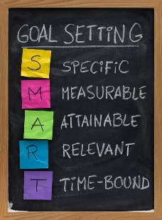 **GOAL STATEMENT:**

I want to improve my mark in math from the first half of semester 2 to the second half of semester 2.

**WHAT DO I NEED TO REACH THIS GOAL? (The steps you**

**must take in order, and the date you wish the step to be**

**completed by.)**

I need to try my best in both half of semester 2 but learn form what I did in the first half. I will also look at and reflect on my workbooks. I will study as hard as I can in both helfs but ill become stronger in the subject.

**HOW ARE YOU GOING TO MEASURE THE PROGRESS TOWARDS**

**YOUR GOAL?**

I will measure my goal by the difference between my two marks and by my average test score.

**OBSTACLES YOU MIGHT SOLUTIONS**

**FACE**

Get tutoring if ii need it and try to ask the teacher for help.

Try to find a new perspective on the subject.

The class may get harder in the second half.

I may lose my passion for the class.

**WHO ARE YOU GOING TO SHARE YOUR GOAL WITH?**

My family and teachers.

**HOW WILL YOU CELEBRATE YOUR GOAL?**

I will celebrate my goal with candy.

**NEVER GIVE UP!**