This Is Easily The Nicest Looking Restaurant I Have Been In

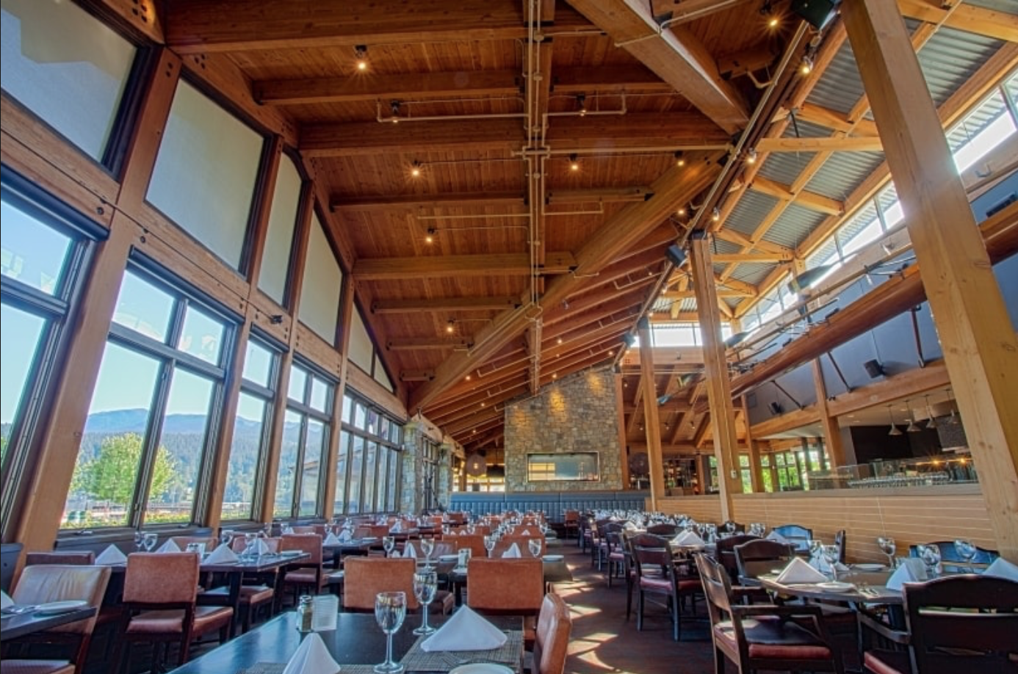
The building looks nice from the outside but when you walk in, you immediately notice the tall ceilings, the humungous brick fireplace, and wooden beams everywhere. The Boat House is a very open and atmospheric restaurant. when walking in, one is immediately treated and seated. if there is no seats available, they kindly ask you to wait its never too long but I like to walk outside and sit on the dock. The experience is premium, as you are given time to talk, socialize but not too much time. If one is in a rush this is not the restaurant for you. The food is superb. Almost anything on the menu will be high quality. Personally, I enjoy the crab and sea food because this is a special occasion restaurant. I have dined there on Birthdays and Fathers Day or Mothers Day. Its perfect of those types of occasions. The atmosphere is very friendly and welcoming, its like home. The waiters, staff are nice and friendly. The thing that I think is perfect about the boathouse is the location in Port Moody right next to the water. The people that made the building had this in mind and it shows with the large windows letting in ample amount of natural light. But with this great new and great food comes a price and its not small but it is manageable, if your not looking to spent more than $100 for 2 or 3 people this isn't the place for you. Its a nice restaurant with great food and a beautiful interior and its great for occasions and I would suggest it or at least try it!

Photo link https://www.weddingwire.ca/restaurant-weddings/the-boathouse-port-moody--e12362

