
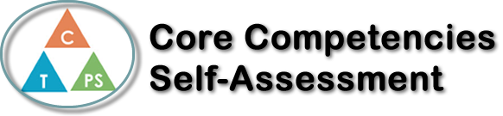
Name: Julia Dunlop | Date: January 17, 2018

  How does the artifact you selected demonstrate strengths & growth in the communication competency?  In what ways might you further develop your communication competency? | Self-Reflection  Describe how the artifact you selected shows your strengths & growth in specific core competencies. The prompt questions on the left - or other self-assessment activities you may have done - may guide your reflection process.  The artifact I chose was communications. It has helped me with speaking, pronunciation, and grammar. I have learned how to properly conjugate verbs through passé compose and imparfait and when to use them. The French trip project has helped me describe what I did, where I went, what I liked, and how I got there through passé compose and imparfait. This project has helped put all my learning into from how to read time to say what I was doing that day. Communication helped me with this project because I had to take my learning and put into a project that had eight or more sentences. My skills with writing in French have grown ever since grade 5 and I can now remember what to say when a stranger starts a conversation with me. The project has allowed me to use my new French writing skills and for me to practice my pronunciation. I was able to communicate with my table group and my teacher when I had questions about the project that I didn’t understand. I would’ve made my presentation more creative for the extra mark but I was more focused on the correct use of passé compose.


How does the artifact you selected demonstrate strengths & growth in the thinking competencies?

In what ways might you further develop your thinking competencies?


How does the artifact you selected demonstrate strengths & growth in the personal & social competencies?

In what ways might you further develop your personal & social competencies?

Publish Your Self Assessment
You will now attach and/or embed your self-assessment to the bottom of the blog post with the artifact you have chosen. You may choose to make this post private or public. After placing your artifact on a blog post, follow the instructions below.
- Categories - Self-Assessment
- Tags - Now tag your post using the tag that corresponds to the competency that you have written about. You can choose more than one. Please use lower case letters and be exact.
  - #creativethinkingcc
  - #communicationcc
  - #criticalthinkingcc
  - #socialresponsibilitycc
  - #personalidentitycc
  - #personalawarenesscc
- Use the Add Document button located at the top of your post page and embed your self-assessment at the bottom of your blog post.
- Publish

