Continental Drift
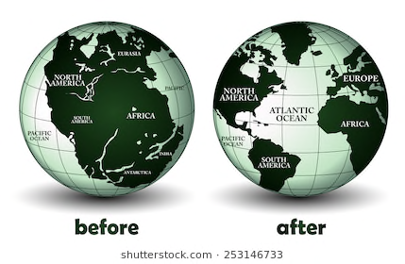
Alfred Wegener

I have come to a realization that the continents are not only moving but used to be all together in one continent, which is called Pangaea. The following evidence and explanations will explain why I believe the continents are drifting.

Puzzle Piece
Have you ever looked at a world map and realized that some of the land masses look like they could fit together like a puzzle piece? The most apparent one is South America and Africa, they look like they would be a perfect fit, like such a perfect fit that would convince me to believe that they were once together. This discovery made me eager to learn more and made me look further the theory. This supports my theory because if the plates drifted apart they would have to fit. Discovery by Alfred Wegener, 1912.
Mesosaurus Fossils Found in Both Africa and South America
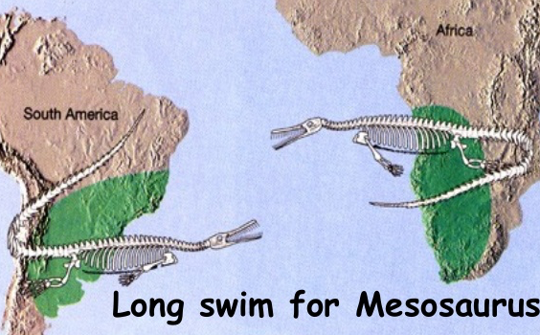
How is this possible? The Mesosaurus could not swim for long distances and Africa is about 10,000km from South America. There is no way the Mesosaurus swam that distance, they aren’t known to swim long distances. The only possibility is that they all started in the same place, but then there lands started drifting from each other, separating the species through continental drifting. This explains Africa and South America looking like they fit, they do fit. In fact they were once together. This supports my theory because my theory of continental drifting is the only explanation for this.

Tropical Fossils Found in the South Pole
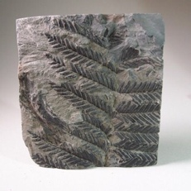
Let me give you a brief background on the South Pole, it is very cold, a max of -90 degrees Celsius cold. The South Pole is too cold for Human life, so what is a Palm tree doing in Antarctica? Palm trees only grow in hot and humid environments, the South Pole is the opposite of that. One of the only ways this could be possible is the world was once in its Pangea form (one big landmass), and the location before Antarctica drifted was a Tropical region. Theoretically Antarctica started out between where Africa and India is now, which is a Hot region, with tropical vegetation growing. This supports my theory because there is no way palm trees would ever grow in Antarctica if the world has always been in the same spot.
Glossopteris
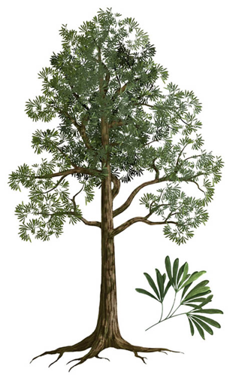
This fern like plant once grew in all the southern continents. Fossils are now found in all the southern continents (South America, Africa, India, Australia and even Antarctica). Which is hard to believe because all these continents are space out and far away, divided by oceans. If the world was really always like this, how did this plant transport to other continents? Plants are indigenous to a certain land, they cannot just decide to move to the other side of the world unless someone plants there seed there. But it would make sense if the continents drifted and all the southern continents took Glossopteris with them. This supports my theory because there in no way this plant traveled across the sea to different continents, they must have all started in the same place.

https://m.youtube.com/watch?v=MLTev3VK_oo

