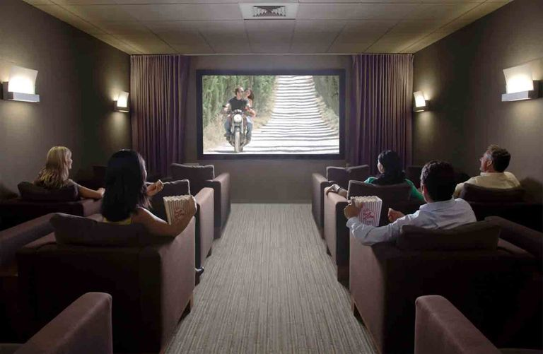
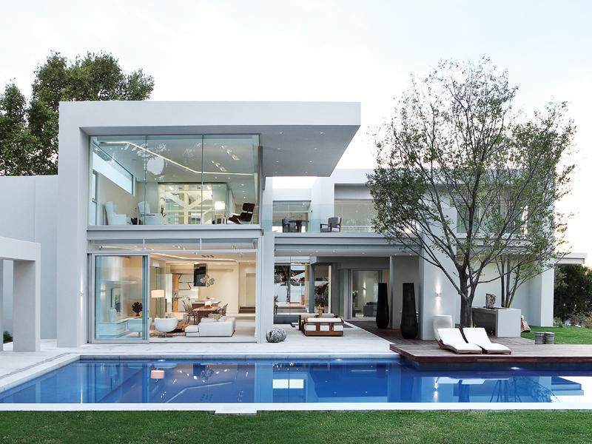

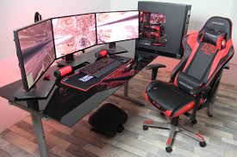
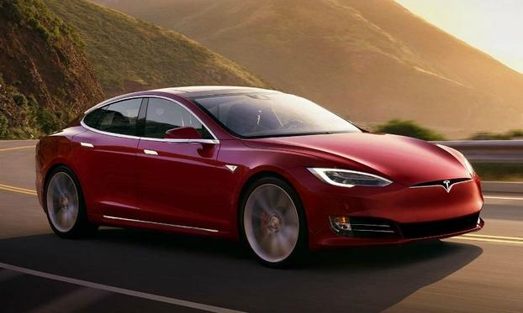
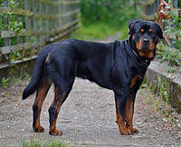
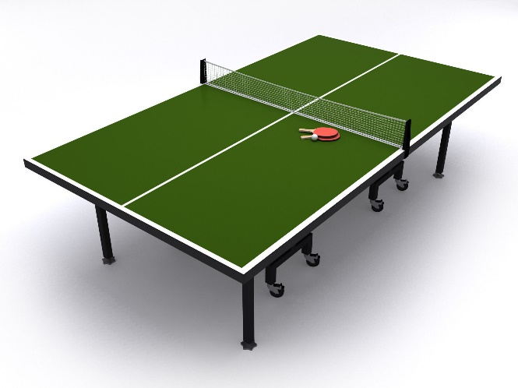
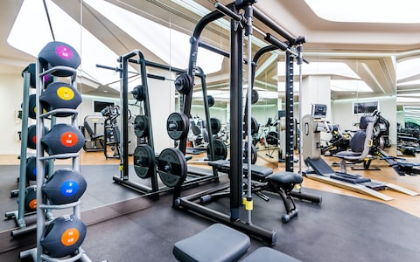

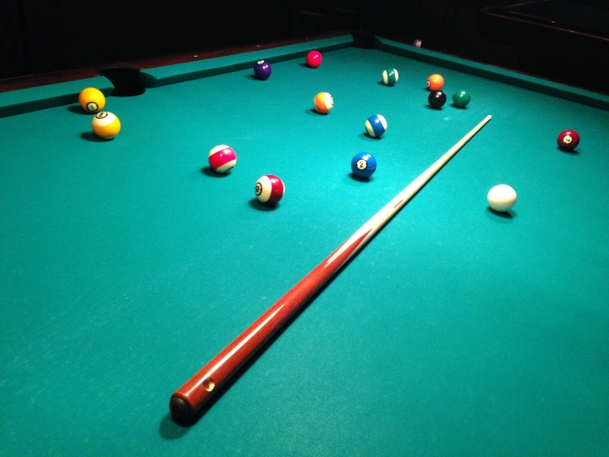

2. My future lifestyle will be very luxurious. A typical day will be wake up, feed my dog, workout for a little bit, go to work, come home go for a swim, play some video games or pool or ping pong. When I go out it will be with friends to fancy restaurants or clubs/concerts. Over all I want a luxurious life.
3. My annual income of a police officer will be $80,000 per year.
4. Cost of a modern home in the lower mainland is $3 million. Cost of Tesla Model S will be $75,200. Cost of home gym will be $8000. Cost of home theater is $10,000. Cost of gaming system is $3200. Ping pong table is $370. Cost of billiard table is $620. Cost of Rottweiler is $5,000. And going out will probably cost me around $600 for a weekend. Total will cost me around $3,129,000.

