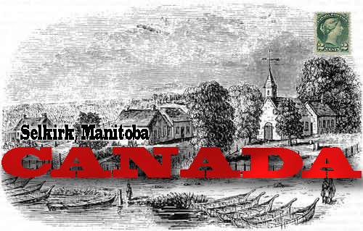
Address: 1234 Devonshire St. London, England.
Dear Father,
It is March 15th 1885. Over the past 17 years a lot has happened, Shortly after I had arrived in the Red River settlement, there was a rebellion by the Metis and their leader Louis Riel but it was far away from me so I was lucky enough not to be involved. After that in 1870 we had joined the rest of Canada as the 5th province named Manitoba. I now live in a town known as Selkirk. I was lucky enough to get a job with the North West Mountain Police. I met a woman named Amelia and married her. We have 2 kids, Charles and James. Charles is 10, and James is 7 both go to an English speaking school. I hope all is well back home.
Your son, Josh

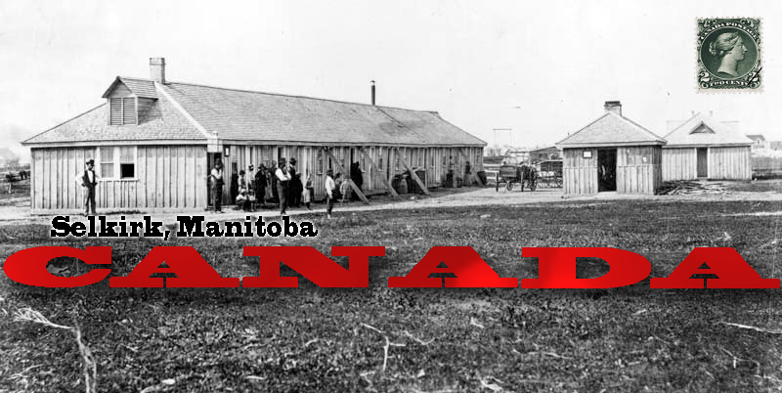
Address: 1234 Devonshire St. London, England.
Dear Father,
It is February 9th 1886. Not a lot has happened over the past year, aside from this winter being very cold and dark. My job at the NWMP has been going quite well but I fear as winter leaves and spring comes in it will get harder. Our prime minister is still John MacDonald, I don’t like him but there is not much I can do about it. Charles, James, and Amelia are all healthy and doing well, which is lucky because I don’t think they could have survived the harsh winter we just had. I hope all is well.
Your son, Josh

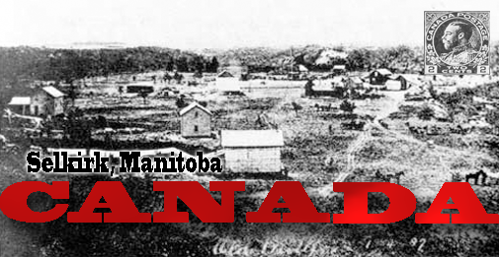

Address: 1234 Devonshire St. London, England.
Dear Father,
It is May 17th 1888. Over the past couple of years some exciting things have happened. My wife, Amelia, is pregnant. I am hoping for another son so that he will be able to get a good job like his siblings, but if I have a daughter I guess she will just have to marry well. Even though I see little action I am still enjoying working as a NWMP officer. Everyone is still healthy and doing good. I hope all is well.
Your son, Josh

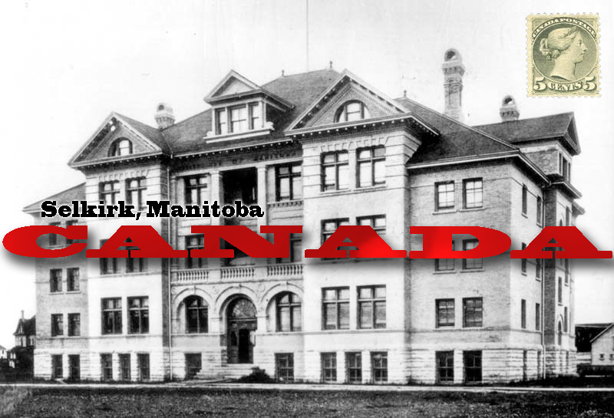
Address: 1234 Devonshire St. London, England.
Dear Father,
It is March 14th 1889. I have some sad news to share with you. My wife, Amelia, had died giving birth to our daughter, Agnes. Her death has been very hard on the kids and they miss her very much. I too miss her very much but I have to move on with life. Tomorrow will be her funeral and it will be the last time I see her. Other than the sad news I just told you there is really nothing else to write about. I hope all is well.
Your son, Josh

Citations:
Clark, Penny , and Roberta McKay. Canada Revisited. Edmonton: Arnold Publishing Ltd, 1992. Print.

