Toronto Daily
August 11th 2005
Subway Assault Ends in Death
Story By: Graham McNamee
Yesterday in the afternoon an attempted mugging resulted in one dead and another in critical condition. Both men involved have not yet been revealed by the police, as they are notifying the next of kin. It is believed that the situation started out side the subway station and quickly escalated. The victim tried to escape by running into the subway station to hide, but unfortunately the mugger had followed him. The mugger pushed the victim into the tracks and was either pulled in or fell in with the victim. The victim was able to lie under the on coming train surviving with critical injuries, but the mugger wasn't as lucky and had died. It is currently unknown the motive of the mugger, but it is believed that the altercation happened with out the two men knowing each other.
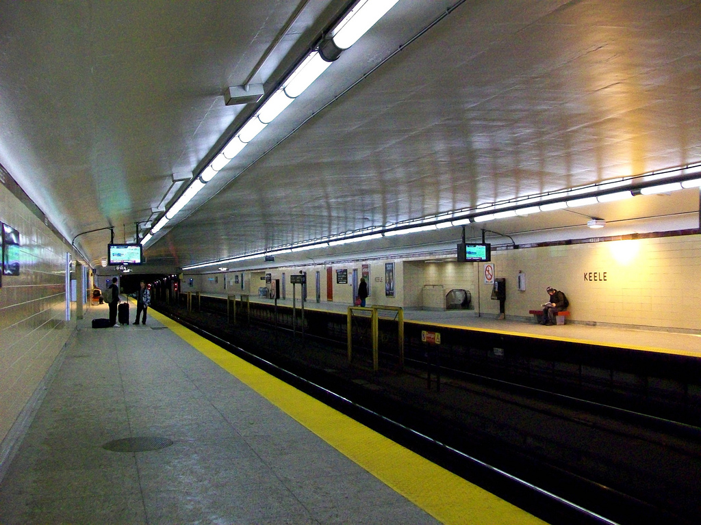
Picture From: https://www.flickr.com/photos/57156785@N02/5456468541

In Sports
In baseball news, the Blue Jays edged out the Detroit Tigers, last night at Rogers Center. Detroit had 2 homeruns with Dmitri Young, hitting one in the 4th and Magglio Ordonez hitting one in the 6th. This nail biter ended with the Bluejays getting the winning run in the 9th with 1 out.

In Weather
This week you should expect to see more sun with the small chance of a bit of rain like we saw the other day. The highs should be 23° Celsius and the low being 7° Celsius.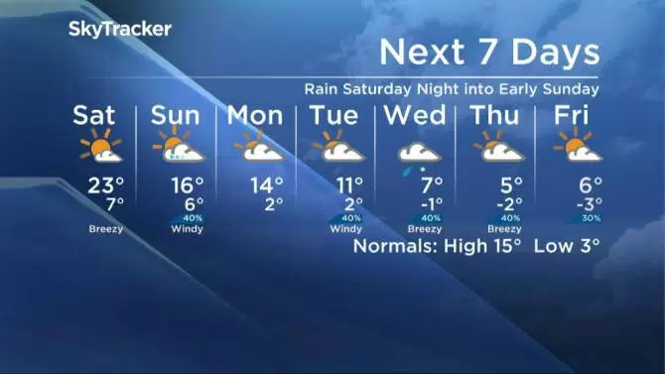
Picture from: Global News

