Jordan Beveridge Independent Investigation: Feb.10th/16

Step 6: Communication of Results

- What was your Question?
Are veggie straws better for you than Lays potato chips?
- What was your hypothesis?
The Lays chips will be better for you because it has very straight forward ingredients so it will be overall better for you than veggie straws.
- What was your independent variable? Dependent variable? Controlled variables?
My independent variable was to compare the ingredients of the two chips and seeing which ones were more healthy. The dependent variable is that it depends which brands you have. I compared veggie straws and Lays potato chips.
4. What did you find out? Was your hypothesis correct?
My hypothesis was incorrect because I found out that the serving size for the veggie straws is almost double the amount compared to the lays. So to compare I double the serving size of the lays, which meant that the nutrition facts would also double and it ended up being more unhealthy than the veggie straws.
5. If you were to do this experiment again, what would you change? Is there another variable you could test?
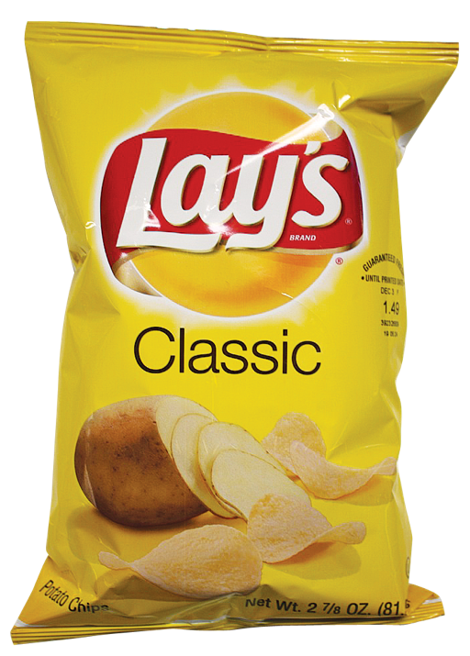
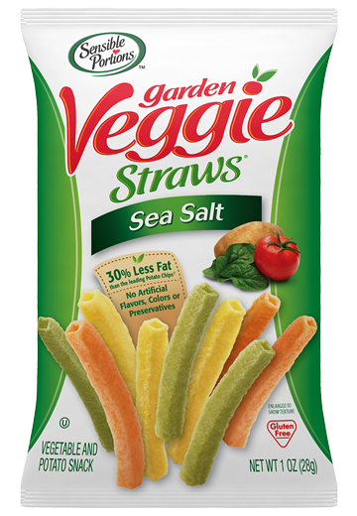
If I did this again I would get different types of chips like using real vegetables and ones people eat instead because they think they’re healthy. Another thing we could test is which chip brand is the most unhealthy.

