Jordan Beveridge Initial Writing Assignment

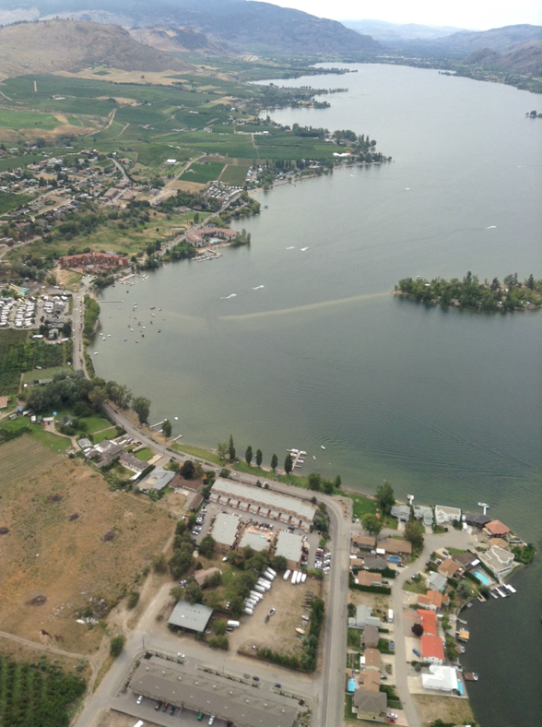
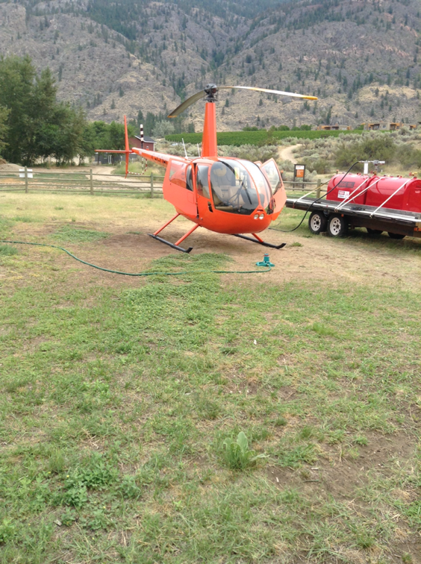
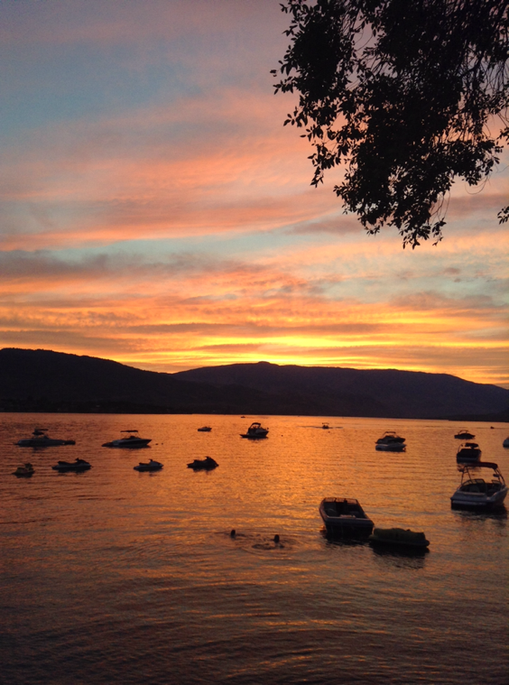
Over the summer break I went to Osoyoos to go camping (or as some people call it glamping because we have a trailer ) with my family. When I arrived to the camp site the first thing I did was go into the lake, it was cold. We stayed at Osoyoos for 2 weeks which felt very long because we had no wifi. We did have tv, which is why I'm still alive. I remember my dad wasn't really liking camping so far because it was so windy and cold outside so we stayed inside for the first week of camping which kinda sucked, but we made the best of it. We played board games, watched Big Brother, watched some movies. We had some amazing dinners made by my dad, like BBQ chicken with mash potatoes and corn. It was Delicious. Also one night we went to a nice restaurant and we had nachos. One of the most exciting parts of the trip was we went on a helicopter which I was so scared because I've never been on a plane. On the last two days of camping we went to visit my nana who we don't see very often. She lives not too far away from Osoyoos. She lives in Penticton. While we were visiting my nana it was the peach festival, so their were rides, concerts, shows, games it was so fun! My nana and I went to a few different shows like the lumberjack show, and we saw this guy that had volunteers come on the stage and he would force them into doing funny things. Also while we were there their was an airplane show. So we stood outside of our hotel and watched the planes do very cool tricks! After visiting with our nana, my day and stepmom picked us up and we went to our campsite to pack everything up and we were on the road. I remember the car ride back felt so long but I was happy to be going home because I really missed having my own space, because being in a trailer for 2 weeks with 4 other people is sometimes annoying… But I had a lot of fun overall. I'm excited to go camping again in the summer.

