Name: Jon Szto BLK: d
Penny Lab
Purpose: To determine how many drops of water fit on one side of a
penny.
Hypothesis: If the liquid placed on the penny increases the surface tension, then the penny will hold more drops of water because the soap will keep the water molecules in place and therefore it will hold more water droplets.

Materials:
- 100ML Glass Beaker
- 50ML Glass Beaker
- Forceps
- Dropper
- Paper Towels
Procedure:
Part A: Perform a CONTROL test for comparison with later results.

Step 1: Rinse a penny in tap water and dry completely.
Step 2: Place the penny on paper towel.
Step 3: Use an eye dropper to place drops of WATER on the penny (one at a time) until ANY amount of water runs over the edge of the penny.
Step 4: Record the number of drops for that trial in the table.
Repeat Steps 1 - 4 three more times before calculating your average.

Number of drops  TRIAL 1 | Number of drops  TRIAL 2 | Number of drops  TRIAL 3 | Number of drops  TRIAL 4 | AVERAGE Number of drops
20 | 13 | 14 | 9 | 14

Part B: Perform tests with the TESTING LIQUID.

Step 1: Start with a “clean” penny. Rinse the penny in tap water and dry completely. Be sure to remove as much residue as possible - without using soap!
Step 2: Hold the penny with the tweezers provided, then dip it into the TESTING LIQUID. Allow extra liquid
to drip off the penny into the container before proceeding to the next step.
Step 3: Place penny on dry spot on a paper towel. Place drops of WATER on the penny (one at a time) until ANY amount of water runs over the edge of the penny.
Step 4: Record your observations and the number of drops for that trial in the table.
Repeat Steps 1 - 4 three more times before calculating the average.

TRIAL 1 | TRIAL 2 | TRIAL 3 | TRIAL 4 | AVERAGE
6 | 5 | 6 | 1 | 5
Observations:
Part One: Labelled Diagram of observations:  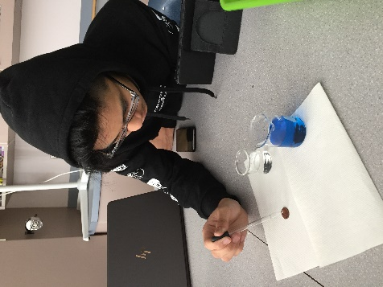 | Part Two: Labelled Diagram of observations:  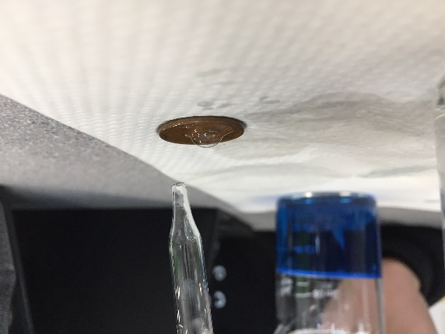  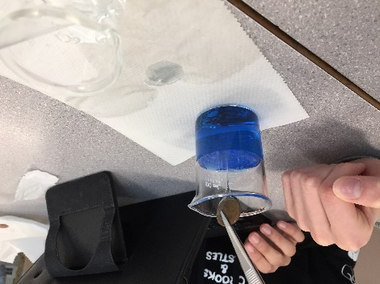
Description: The pennies held on average 14 drops of water after 4 trials. | Description: The pennies held on average 5 drops of water. The water’s cohesion forces broke quickly with the addition of the soap.
Results:
Group # | Average Number of water Drops on the Control Penny | Average Number of Drops on the  Penny submersed in the soap solution
Group One | 20 | 9
Group Two | 25 | 8
Group Three | 26 | 6
Group Four | 23 | 7
Group Five | 22 | 9
Group Six | 14 | 5
Class Average: | 22 | 7

Conclusion:

This experiment investigated whether or not the soap solution would strengthen or weaken the cohesion force of the water on a penny. In order to study the problem, water was dropped onto a penny with and without a soap solution with an eye dropper one drop at a time in this experiment, the penny without the soap solution on average held 14 drops of water after 4 trials, and the soap coated penny held on average 5 drops of water after 4 trials. Results showed that the pennies coated with a soap solution resulted in a lot lower average of drops held compared to the pennies without a coat of soap. This proved that the hypothesis that if the liquid placed on the penny increases the surface tension, then the penny will hold more drops of water because the soap will keep the water molecules in place and therefore it will hold more water droplets was negated because the soap’s molecules broke the surface tension of the water molecules. It disturbed the water’s cohesion forces and the water molecule’s cohesive properties. Our results were under average compared to the rest of the class’s with 14 drops for the clean penny and 5 drops for the coated penny. This could have been because of the cleanliness of the penny, or the amount of soap solution added to the penny. The more soap that the penny was coated in, the less water drops it could hold according to our results. To extend this experiment, different solutions could have been used. A diverse selection of soap-like solutions could have identified the causing factor of the break of surface tension in the water. Finally, if the experiment was repeated, some changes to improve the experimental design could be to use set amounts of soap to more accurately identify the effects on the water. Pennies with rust should have also been avoided as the rusty pennies showed a minor difference in results compared to the other ones.

