Float Your Boat Challenge
By: Jon Szto
Group Members: Kai, Tyler
Science 10 Block D

Problem: We need to create a boat that can hold as many pennies as possible.

Hypothesis: If the structure is strong and balanced, then the boat will hold the greatest quantity of pennies because it will be able to hold the pennies with a strong structure and stay afloat balanced.

Observations:
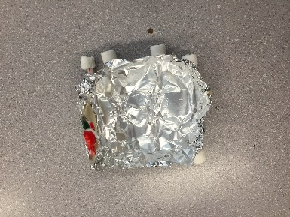
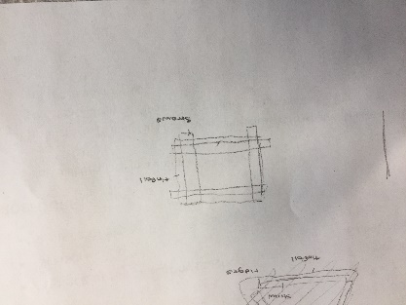
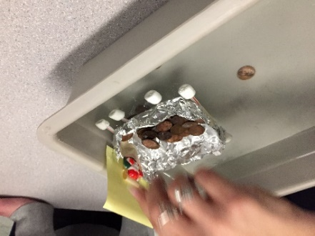
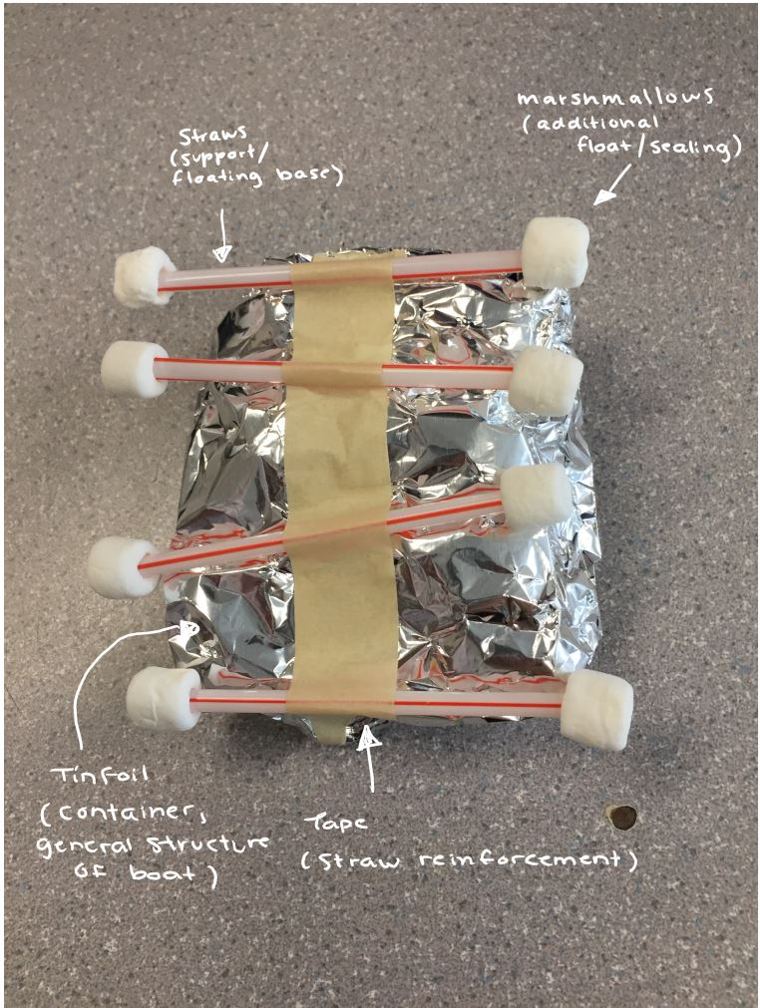

Results and Conclusions:
The boat held… 77 pennies.

The original thinking and reasoning behind the design was…
To create a large surface to create buoyancy and keep the platform afloat for as long as possible.
If the following challenge was repeated, to improve the boat design, the following changes would be made…. because….

I would create a stronger container with the tinfoil to make sure the structure can properly contain the pennies, and then straighten out the straws and make sure the entire boat would be properly balanced. I would do this because our boat sunk due to the unbalanced straws. By improving our design, the boat would have avoided the unbalanced sinking that it experienced as the container would properly support the pennies and the straws would keep it afloat and balanced.

