Linear relations occur in the world when two things are related in a simple, proportional way. For example the number of tires on one bicycle is 2. If I have four bicycles, I have 8 tires.
Here is a table of values showing this proportional relationship
Number of Bicycles | 1 | 2 | 3 | 4
Number of tires | 2 | 4 | 6 | 8

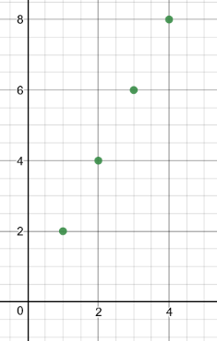
When a linear relation is graphed, it looks like a straight line. Here is a graph of the relationships above.

Notice for this graph, the variables are discrete, so it is a graphed as points that are not
Connected. Discrete variables are items that can be counted. The number of bicycles appears
On the horizontal axis. The number of tires appears on the vertical axis.

To help introduce the concept of linear relations in a relevant way, you will investigate wages. This also related to our finance unit and how we can think about saving money.
1. Choose two different jobs that you might like to do in the next 5 years. The jobs must pay an hourly wage.
Job # 1 Babysitting Job # 2 Cashier

2. Find reliable Canadian internet sources to get information about the 2 jobs:
- What is the hourly wage for each job? Make sure they are different.

Job # 1 $12 Job # 2 $11.15

3. A) Fill in a table of values for each job.
Number of Hours | Total Pay
0 | 0
1 | 12
2 | 24
3 | 36
4 | 48
5 | 60
6 | 72
7 | 84
8 | 96
9 | 108
10 | 120
20 | 240
40 | 480
100 | 1,200
X (an unknown number of hours) | X(12)

Number of Hours | Total Pay
0 | 0
1 | 11.15
2 | 22.30
3 | 33.45
4 | 44.60
5 | 55.75
6 | 66.90
7 | 78.05
8 | 89.20
9 | 100.35
10 | 111.50
20 | 223
40 | 446
100 | 1,115
X (an unknown number of hours) | X(11.15)

B) Can you write an equation relating the hours worked (h) and wages earned (W)?
H(W) = money h(12)= money
4. Graph the two tables on graph paper. (Or if you prefer, use your device or desmos to make a digital
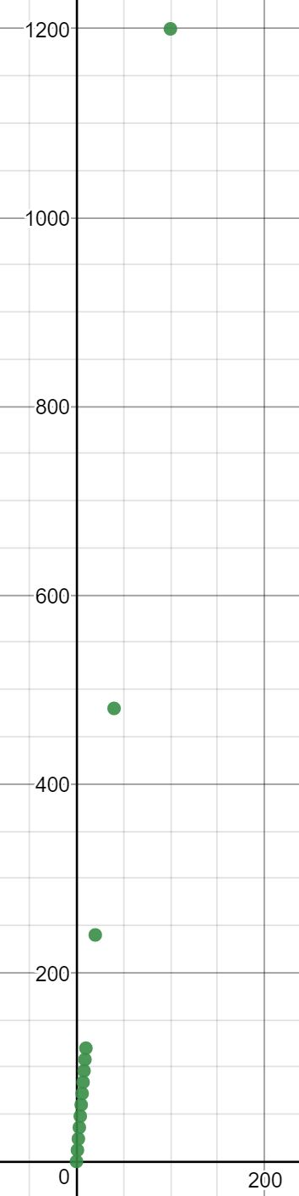0 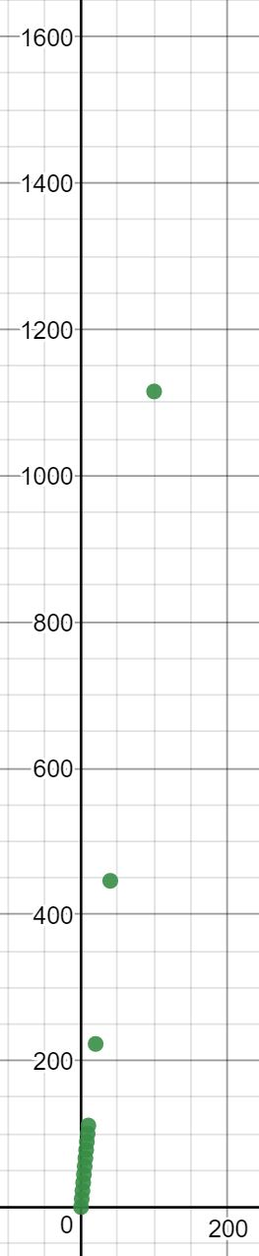
5. Which of these two jobs would you prefer to have based on this information and why? What are some other factors to consider when comparing the two jobs?
Cashier, because it’s a more reliable job on a reliable pay.
Although babysitting has a higher pay, finding a reliable job is more important.

6. You want to save $1,000. Pick one of the jobs. State how many hours a week you could work while going to school. How long will it take to save the money, assuming you have no expenses or taxes to pay?
I would pick the cashier job. I would work approximately 90 hours.
To get the 90 hours, I’d work from 4-8 everyday after school. With four hours a day, it would take me around 23 days to earn $1000.

7. Share your findings with your parents/guardians and have a discussion about this assignment. What have you found out that you didn’t know before?
I was able to explore the job wages on the internet. They were all a cool finding and having a general idea of the amount of pay for certain teenage jobs is always great to know.

