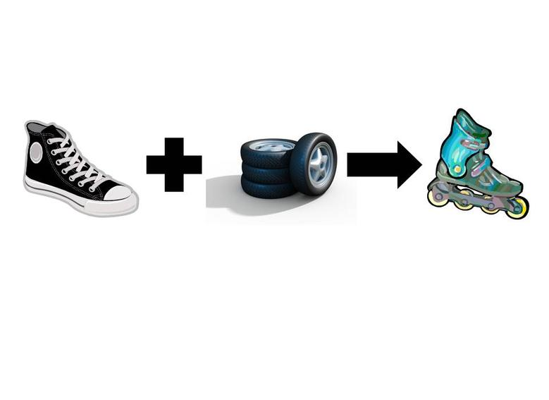
Synthesis reactions
A+B->SB
C+O->CO₂

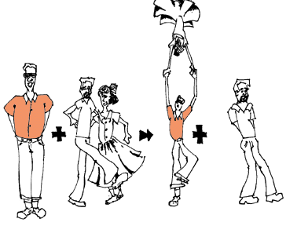
Single replacement reactions
A+CB->C+AB
ZN+CuCl₂->ZnCl₂+Cu

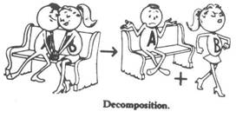
Decomposition reactions
AB->A+B
CO₂->C+O₂

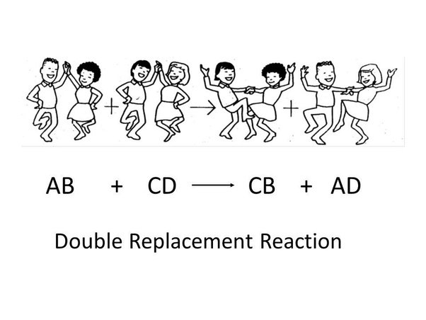
Double Replacement Reactions
AB+CD->CB+AD
Na₂S+HCl->NaCl+H₂S

