My favorite places
My favorite is a swimming pool
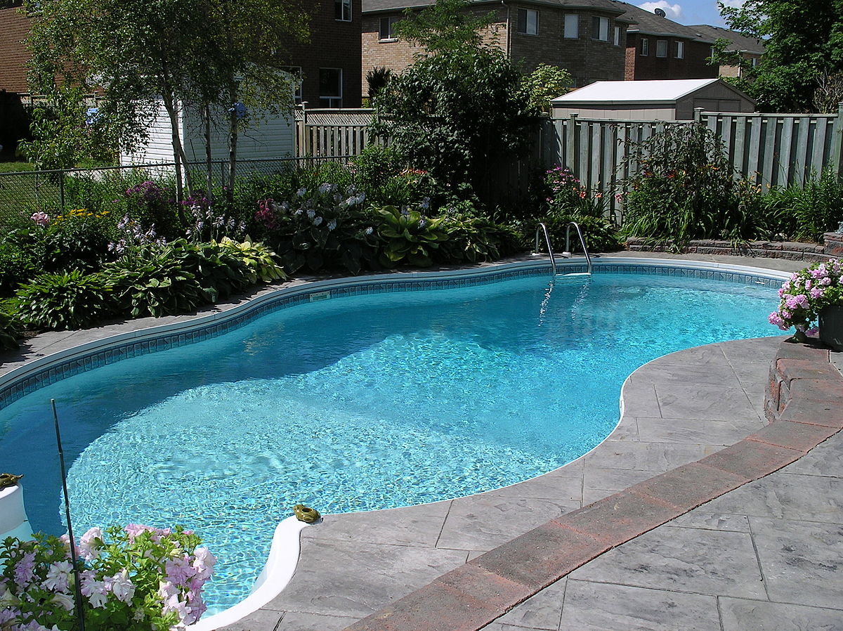
When I go to the swimming pool I feel free and when you jump into the water is feel so cold (in summer)
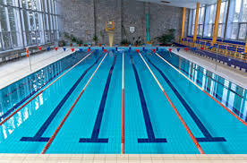
When I’m in the water I think my weight is 0 kg, my legs don’t have carry my body, so I feel relaxed
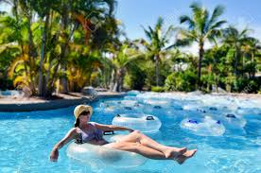
But have 1 time, I jump into the water, that pool is 20m dip, then the goggle was broke, so the water is all in my eyes, then I can’t see where should I go, after like a 5s, someone pull me out.

