Shakespeare Reflection
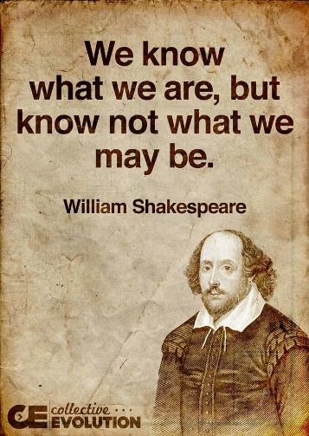
The Oral Language section of the curriculum focusses on
• Purposes – providing opportunities for students to develop their capacity to interact effectively with peers and adults, to present material orally, to question, to explain, to persuade, and to listen attentively, respectfully, critically, and with purpose
• Strategies – increasing students’ awareness of, engagement in, and development of the processes, skills, and techniques they can use to be more successful in their oral interactions and presentations
• Thinking – extending students’ capacity to use oral language to make connections, develop ideas, consider multiple perspectives, increase vocabulary, and use metacognition to assess their strengths and set goals to scaffold improvement
• Features – increasing students’ knowledge of the forms of oral expression and the expectations of various audiences, as well as their capacity to control syntax, diction, and other aspects of oral communication

- Do you think the workshop was a valuable way to learn this?

- What did you like about the workshop?

- What did you dislike about the workshop?

- What do you remember learning that has stuck with you?

- Do you think the English department should do this again?

