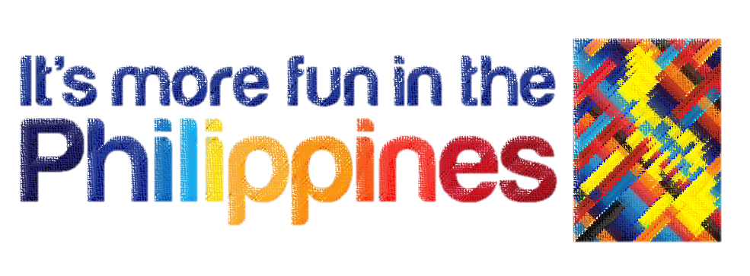

Geography
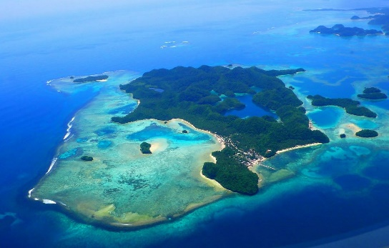
- Landscapes
The Philippines is an archipelago that consists of 7,107 islands in total. It has an area of 300,00 square kilometres approximately.
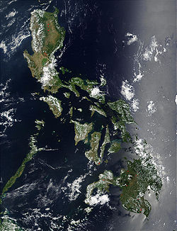
Albeit all of those, Philippines is only divided with 3 main islands. Which is Luzon, the national capital; Visayas, the central part of the Philippines; and Mindanao, the lowest part of the Philippines.
- Temperature
Due to Philippines being near in the equator, it only has two season – summer and winter. It never snows, however. May has the hottest month while the coldest month is in January. The wettest month belongs to August.

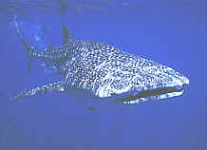
- Features
Many different islands of Philippines have a lot to offer. From snorkelling in the coral waters to swimming with whale sharks. From the Rice Terraces to Chocolate Hills.

Population
- Languages
Around 120 – 175 languages are spoken in Philippines. Despite all of that, the most spoken language is Tagalog / Filipino. Some or most people also speaks English, especially in Luzon.
- Religions
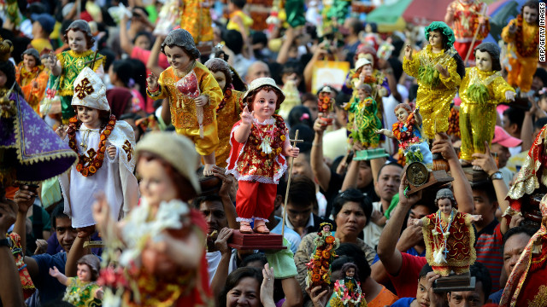
There are variety of religions in different parts of the Philippines. – Also the one and only Christian nation in Asia. Mindanao is mostly Muslim. Around 90% is Roman Catholic. Some are Christians. And the latter belongs to the Protestant denominations.

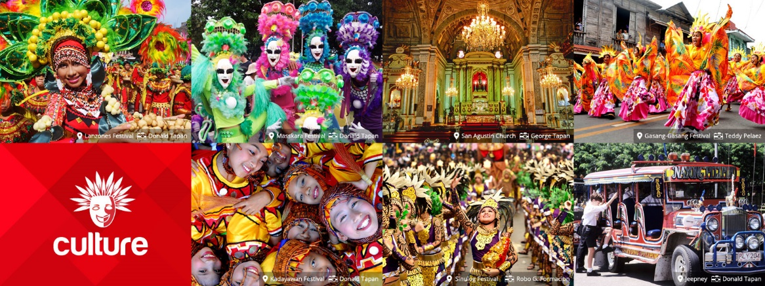
- Traditions and Culture
Due to the influence of the Catholic religion, Philippines has many festivals and it happens every year. If you like colourful and fun fiestas, Philippines is a must to visit.
Example of a fiesta is Flores de Mayo or “Flowers of May.” A month-long festival that celebrates the honour or the Holy Mary.
- Living
The Philippines is known for its people to be friendly and caring. Philippines is a breed from many different countries. The Philippines is a developing, yet a country rich in nature. It has a very high quality standard of living at a very low cost. Cheap taxis, high quality, yet cheap rental homes. You can also have a fun night from golfing, international restaurants, and very easy to start a business with.

Industry
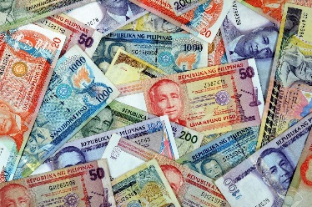
- Currency
Philippines uses a currency called “pesos.” But you can also change currencies in banks. For example, $1 can be exchange with Php. 35.

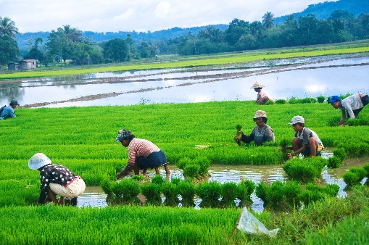
- Industries and Agriculture
Philippine is rich in nature. So we are rich in farming, fishing, etc. While all of that, some industries of the Philippines include electronics, business, food manufacturing, shipbuilding, chemicals, textiles, garments, metals, refining, etc.

Tourism Highlights
- Why visit?
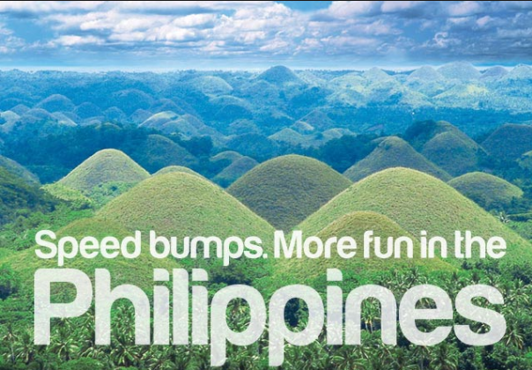
Like mentioned many times earlier, Philippines is a good natural source of nature beauty. From man-made to natural. Enjoy the natural beauty in different islands like Palawan, Hundred Islands, Diving underwater, Nature / Wildlife. 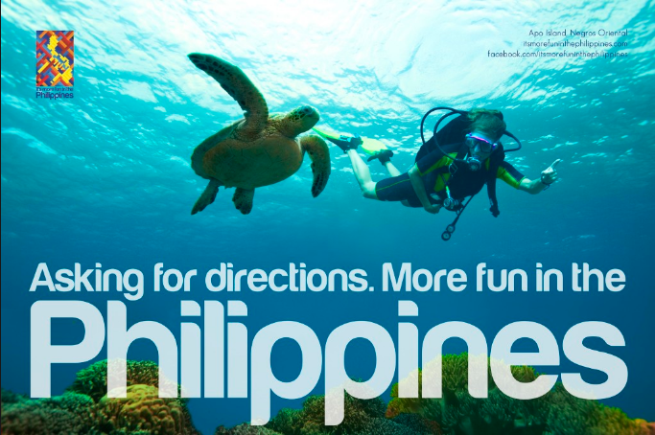

- Must Things to Do
  - Food Trip
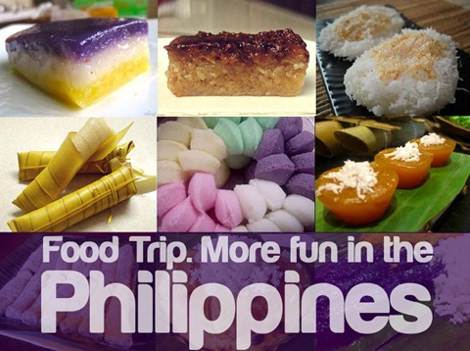
When it comes to Philippines, the answer is always food trip. The Philippines has a lot to offer when it comes to their foods and snacks. They’re safe to eat and super delicious! The most popular Philippine food for the foreigners to try is “Balut,” or an egg with a chick or a duckling inside.

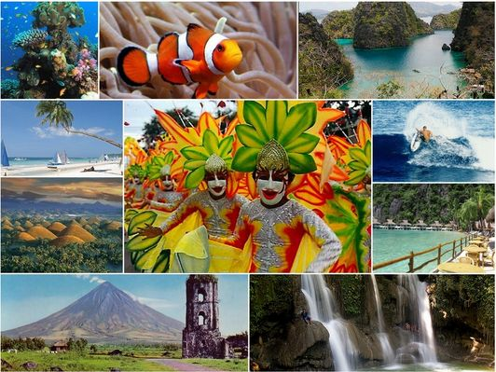
  - EXPLORE!

Explore! Philippines has a lot of beautiful places, attractions, and festivals for you to see and to do! Different fiestas. Underwater and underground adventures. Beautiful sceneries! Philippines have it all!

  - Places to Visit
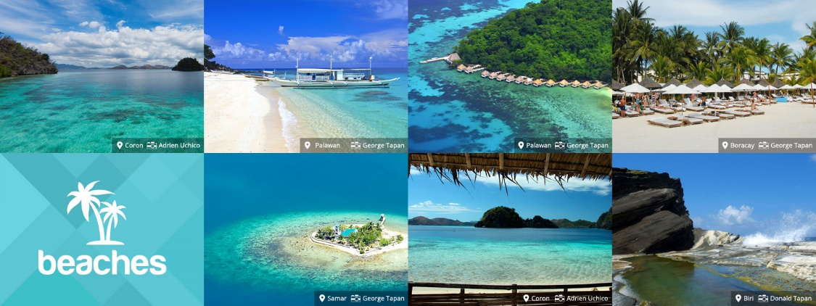

Beaches! Albeit having such a hot temperature, Philippines has a lot of beautiful beaches to offer! From Luzon to Visayas. Visit them and enjoy their beautiful scene especially on hot days.
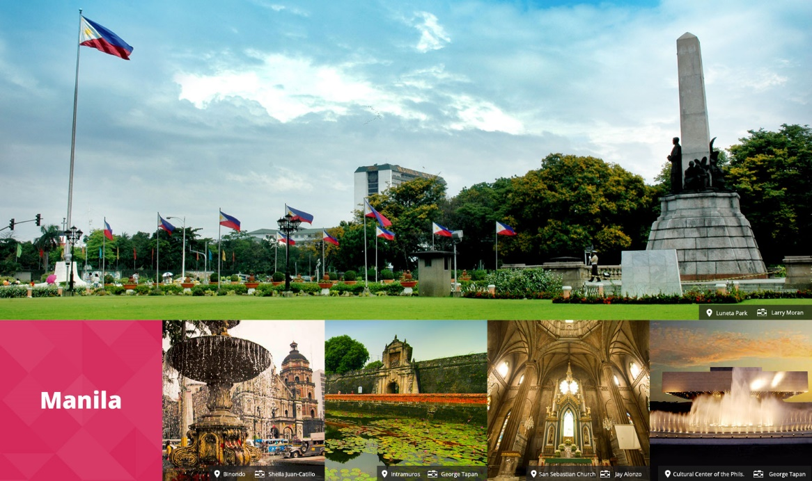
Manila! If we speak of Philippines, we think of Manila, the capital country of the Philippines. Monuments, gorgeous places, and ancient buildings. And most of all, the Luneta Park! A park for one of the most heroic Filipino, Jose P. Rizal.

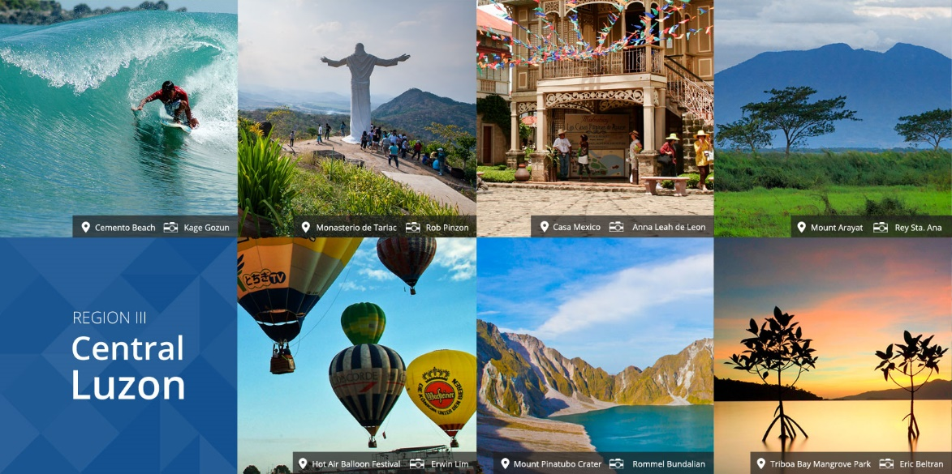
Central Luzon! Visit the beautiful places, surfing, and hot-air balloons! And the most popular of all, “Kamay ni Hesus,” or “Hand of Jesus.”

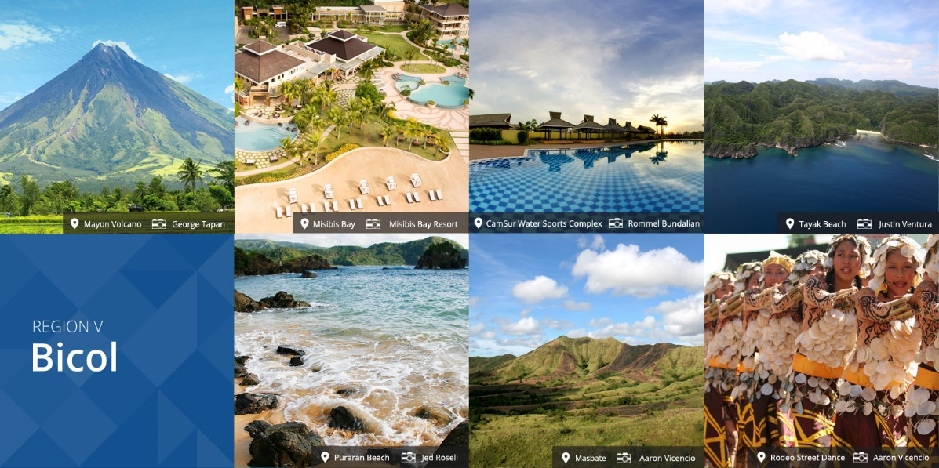
Bicol! Visit them and be welcomed by the warm and traditional people! Visit it and see one of the most popular tourist attraction in the Philippines – The Mayon Volcano!

- Top 10
  - Tourist Attractions

