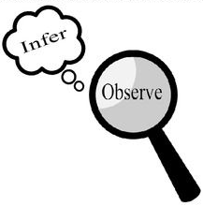
Observations and Inferences
Science 10 Name: Jeremy Zhao BLK: C

OBJECT | OBSERVATIONS  Words that describe the object | INFERENCES  Ie: Where might the object come from? Possible uses? Etc. | QUESTIONS YOU HAVE ABOUT THE OBJECT
A | Blue, transparent, good smell, certain consistence | Might be some form of soap, use for cleaning dishes, cloths of hands. | What kind of liquid is it? Why is it blue?
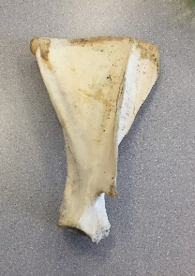  B | White, rigid, dense, | Might be some sort of bone. | What kind of bone is it?
C | White yellow ish, rigid, dense, have sharp teeth | Might be a skull of some sort of Canidae | What kind of skull is it? What is it yellow ish?
D | Light, transparent, the rubber needle can be remove | Might be a dropper | Is it a dropper?

