Float Your Boat Challenge
By: Jenna Milot
Group Members: Ben and Majid
Science 10 Block D

Problem: To create a supportive boat to help the pennies float and to support as much weight as possible with limited resources.

Hypothesis: If the weight distribution of the boat is even, then it will support more pennies
Observations:
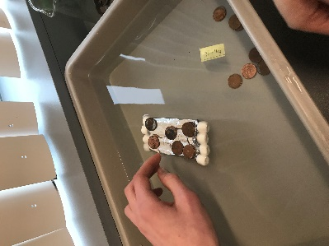
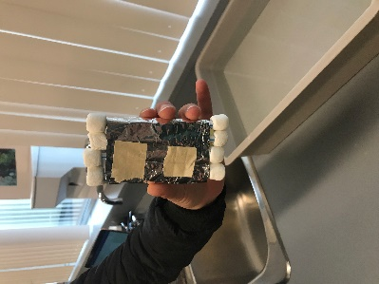
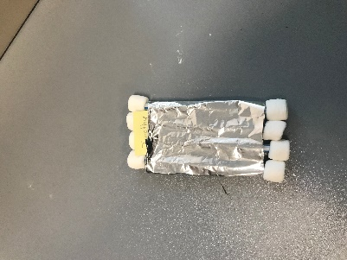

Top view Bottom view In action
Results and Conclusions:
The boat held… 9 pennies

The original thinking and reasoning behind the design was…
Originally we were going to do a design where the straws were wrapped around the edges and then the tin foil was in the center, but we decided to change it to this design. The plan behind it was so the weight would be evenly distributed.

If the following challenge was repeated, to improve the boat design, the following changes would be made….because….
I would change the whole design, the surface area was too small and could not fit many pennies on it, if it was bigger I think we would have been able to hold more pennies. I think a circular shape would have had success.

