Lunch
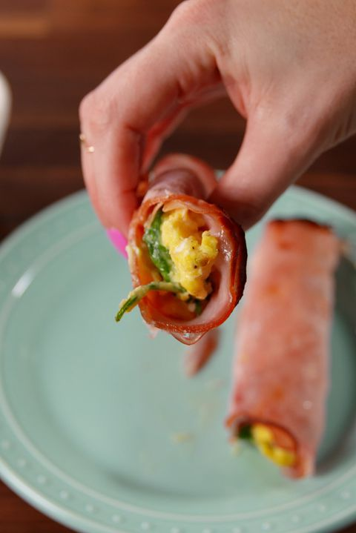
Ham Egg & Cheese Roll-Ups
- 5 eggs
- 5 ml garlic powder
- kosher salt
- Freshly ground black pepper
- 15 ml of butter
- 175 ml shredded Cheddar
- 120 ml baby spinach
- 10 slices ham

- Heat broiler. In a large bowl, crack eggs. Whisk together with garlic powder and season with salt and pepper.
- In a large nonstick skillet over medium heat, melt butter. Add eggs and scramble, stirring occasionally, 3 minutes. Stir in cheddar until melted, then stir in baby spinach and tomatoes until combined.
- On a cutting board, place two slices of ham. Top with a big spoonful of scrambled eggs and roll up. Repeat with remaining ham and scrambled eggs.
- Place roll-ups in a shallow baking dish and broil until ham is crispy, 5 minutes.
Breakfast
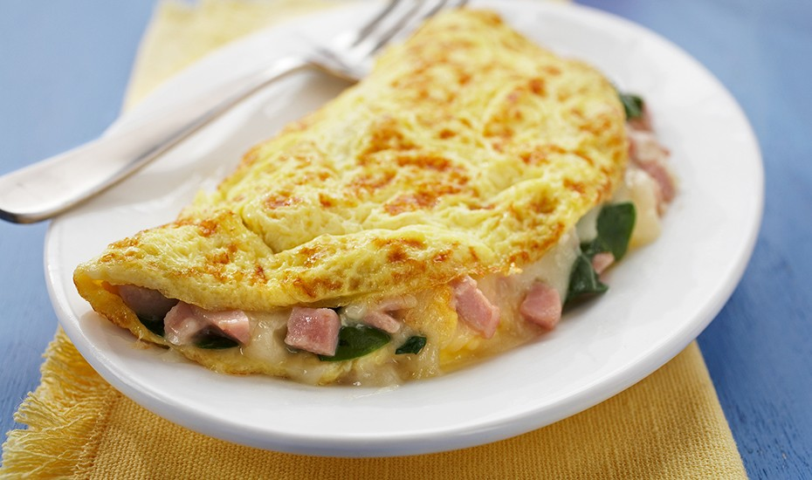
Egg omelet
2 | EGGS
30ml | water
a pinch. | salt
Dash | pepper
5ml | butter
80ml | filling,
- BEAT eggs, water, salt and pepper in small bowl until blended.
- HEAT butter in 6 to 8-inch nonstick omelet pan or skillet over medium-high heat until hot. TILT pan to coat bottom. POUR IN egg mixture. Mixture should set immediately at edges.
- GENTLY PUSH cooked portions from edges toward the center with inverted turner so that uncooked eggs can reach the hot pan surface. CONTINUE cooking, tilting pan and gently moving cooked portions as needed.
- When top surface of eggs is thickened and no visible liquid egg remains, PLACE filling on one side of the omelet. FOLD omelet in half with turner. With a quick flip of the wrist, turn pan and INVERT or SLIDE omelet onto plate. SERVE immediately.

Dinner
Twice Baked Potato with Egg on Top
• 2 medium/large potatoes
• 1 medium yellow onion, diced
• 4 small eggs
• 3 or 4 cloves of garlic, chopped fine
• 100 ml cheese, grated
• 30 ml olive oil
• Fresh chives, chopped
• Salt and freshly ground black pepper

- Preheat oven to 200°C (400°F). Scrub potatoes, pierce them with a fork and put them in the oven rack for 30-40 minutes until soft.
- In a large frying pan heat oil or butter over medium high heat. Sautee the onion with garlic for about 5 minutes until soft.
- When the potatoes are cool enough to handle cut potatoes in half lengthwise, scoop the interior out of each leaving about 1/4-inch shell of potato flesh and skin. Add the scooped-out potato flesh, grated cheese, salt and pepper into the pan and stir well to combine.
- Place the potato shells on the baking sheet and feel them with the mixture. Press the mixture with a spoon so a whole is formed to make space for the eggs. Sprinkle chives on top and crack an egg on top of each stuffed potato.
- Cook at 200°C (400°F) for 10-15 minutes until the egg is set. The whites are set while the yolks are a bit runny. Enjoy!

