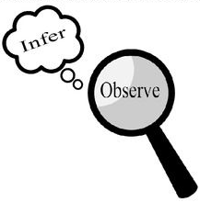
Observations and Inferences
Science 10 Name: BLK:

OBJECT | OBSERVATIONS  Words that describe the object | INFERENCES  Ie: Where might the object come from? Possible uses? Etc. | QUESTIONS YOU HAVE ABOUT THE OBJECT
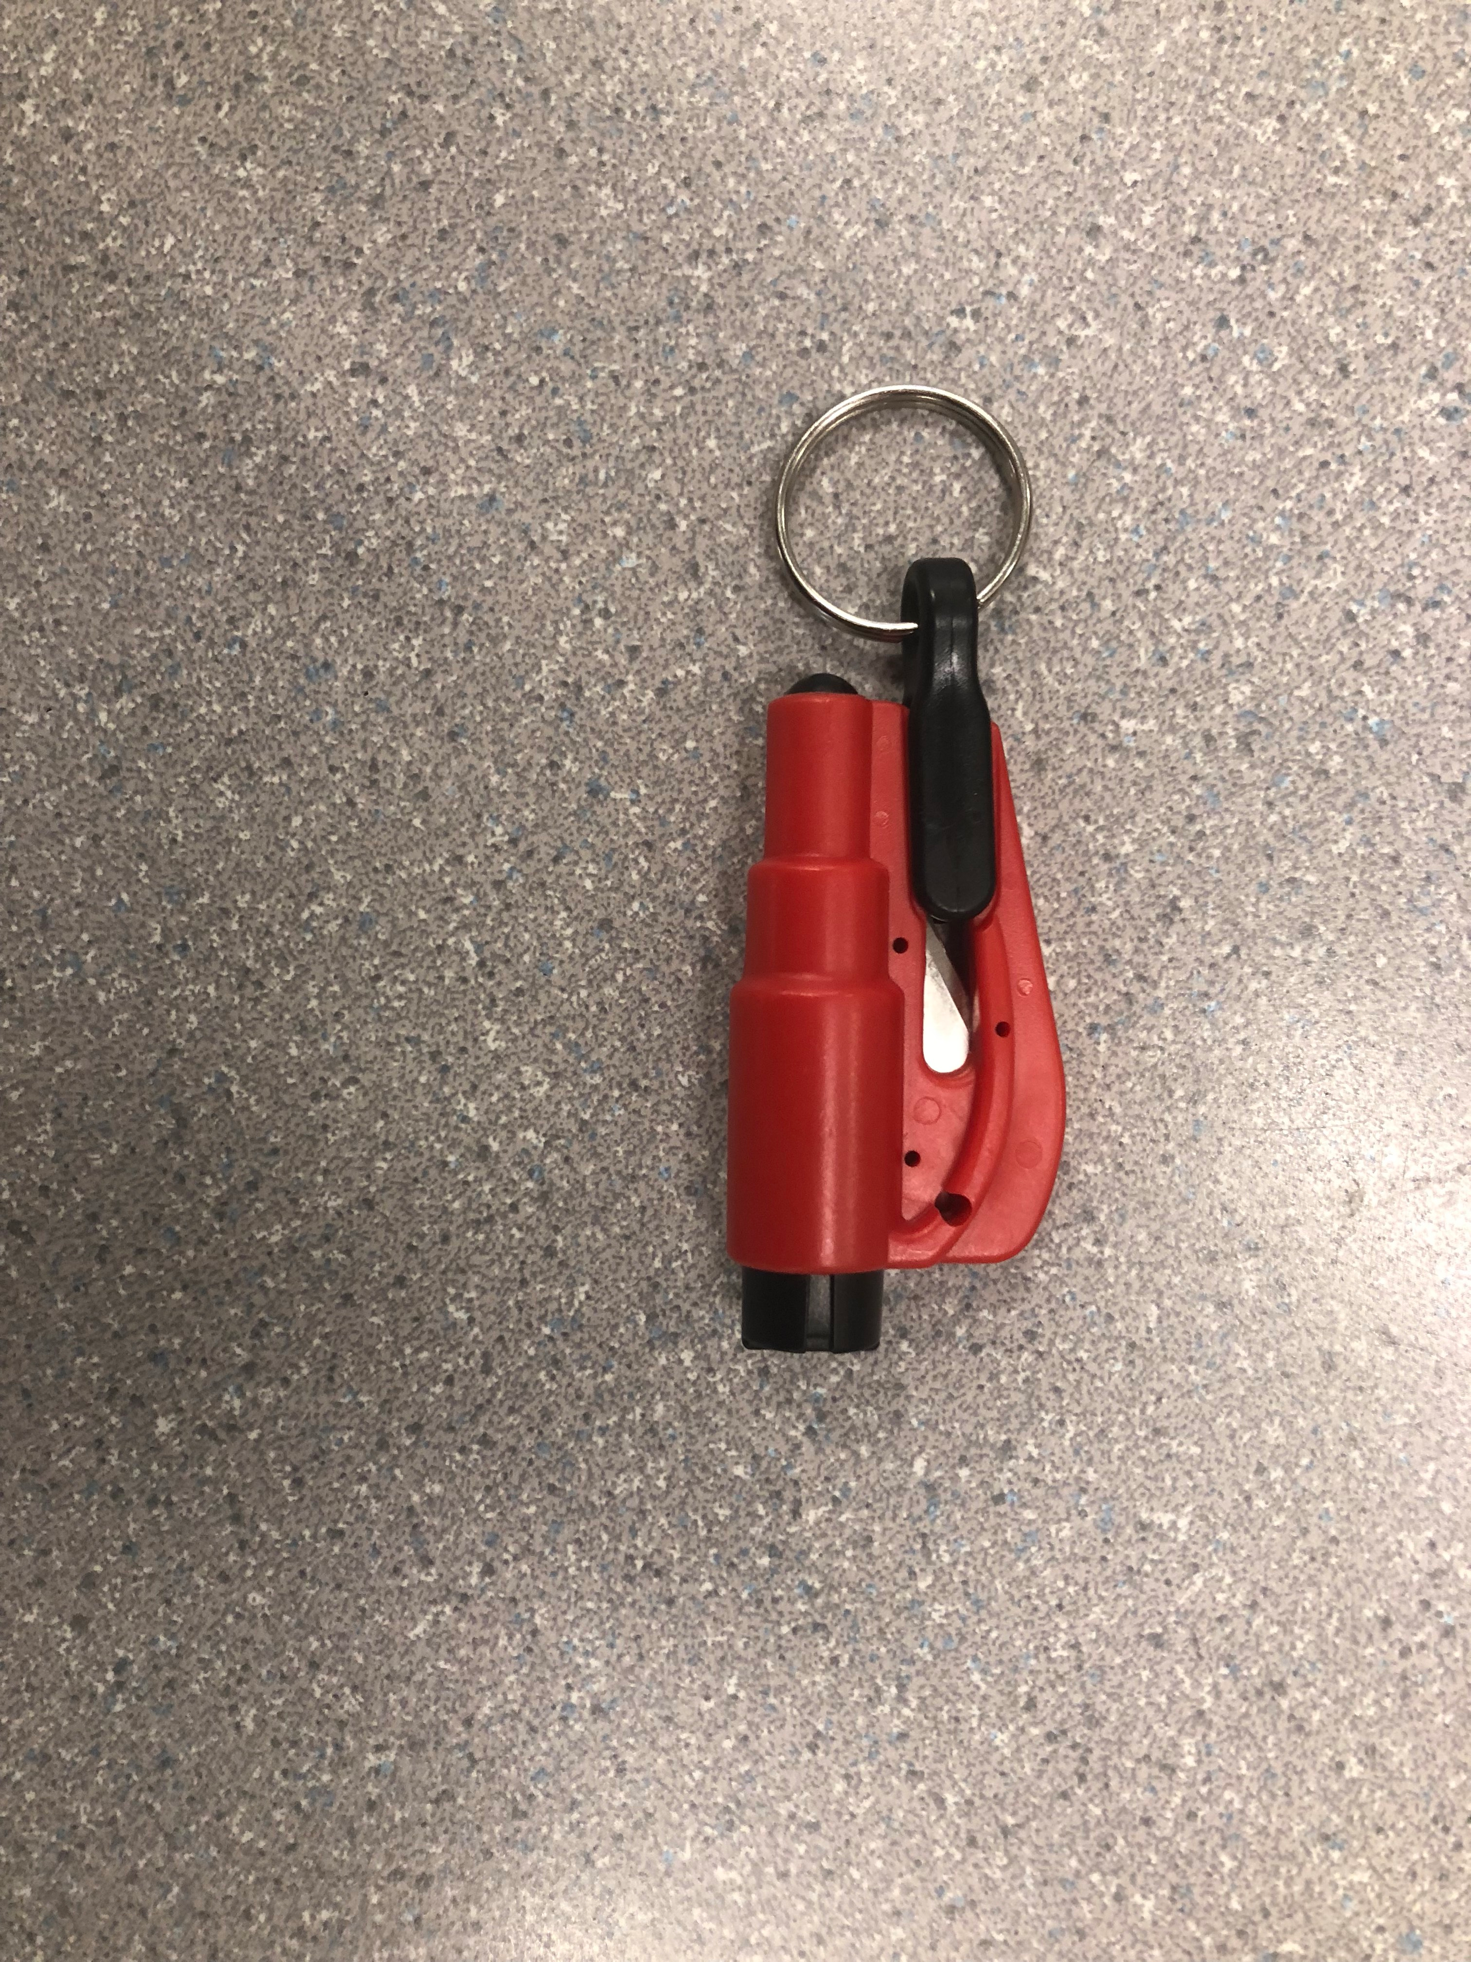 | The color is red and black.  There is a blade and a plug to protect it.  The plug can be pulled.  No smell.  Made by plastic and metal.  A key ring on the plug | It is made from a factory and many of them are made in the factory.  The blade is for cutting the seat belt when people stuck in the car and the seat belt release button is malfunction.  The black “hammer” that will pop a blade to break a window when the car door cannot be open, and people need to get out.  The key ring is to hang on the car key, so people can carry it with their key. | How powerful is the “hammer”? How sharp is the blade?  How does the hammer works
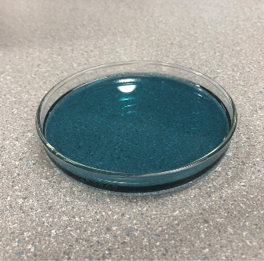 | It’s liquid.  The color is blue.  The liquid is very thick.  It has a smell comes from chemical  It is partly translucent | This object might come from a factory.  This liquid is for cleaning use like laundry detergent or dish detergent. | what is the chemical it contains?
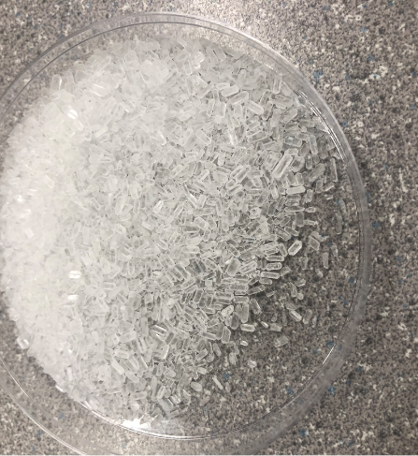 | There are many small particles.  Each particle has cylinder shape.  It has a refreshing smell.  Each particles’ shape is very similar.  Looks like MSG. | It is manufactured in a factory.  This is might can improve the smell of the room.  Or seasoning. | What gives the smell?  Why does it smell that way?
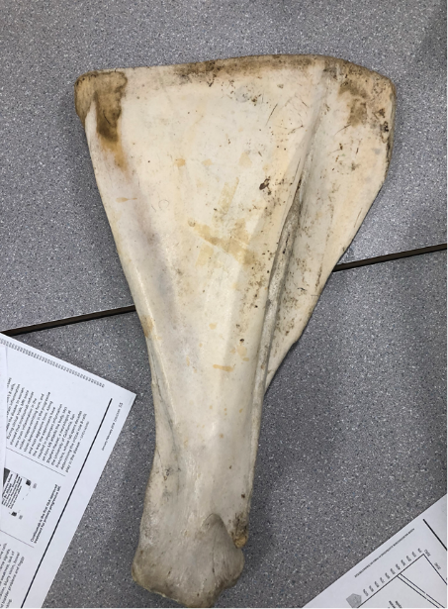 | It has a triangular shape.  The color is white, and some part is yellow.  It has an extrude on one side.  It is flat on one side.  The other side is cylinder | It is a bone from an animal.  Might be the bones on the shoulder.  It is joint with other bones on one side. | Why does it shape that way?  What is the function of the object?  Where does it located?  What kind of animal does this object belonged.

Observations/Inferences Assignment Assessment
Name: _____________________
Ex: Excellent VG: Very Good G: Good S: Satisfactory IN: Improvement is needed
Criteria | IN | S | G | VG | Ex
The following is included
- All 4 Images included
Observations:
- A minimum of 5 detailed observations made
Inferences:
- Thoughtful and logical inferences made
Questions:
- 2 thoughtful and logical questions made
- Spelling/grammar
- Assignment was completed on time
/10

