
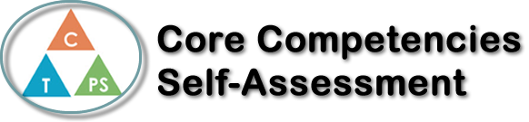
Name: Jason Shaw | Date: March 16th

  X  How does the artifact you selected demonstrate strengths & growth in the communication competency?  In what ways might you further develop your communication competency? | Self-Reflection  This project showed our team was trusting and able to work as a team for example the members of my group trusted me to perform “CPR” on him and we spent some time before the project formulate a plan and execute it, if he hadn’t of done that we would have been lost when we were recording it. First aid is an extremely important thing it know how to do, whether it be helping someone with a cold or helping a unconscious person, first aid is or at least I think it is an essential in this day where anything can happen at any second, having someone that knows what to do when another is hurt/sick is very good, I’m glad that I learned how to do this, because first aid is such an important thing and its very good to see that kids in school are learning how to do this the proper way and that it is an essential part of our curriculum.


How does the artifact you selected demonstrate strengths & growth in the thinking competencies?

In what ways might you further develop your thinking competencies?


How does the artifact you selected demonstrate strengths & growth in the personal & social competencies?

In what ways might you further develop your personal & social competencies?

Publish Your Self Assessment
You will now attach and/or embed your self-assessment to the bottom of the blog post with the artifact you have chosen. You may choose to make this post private or public. After placing your artifact on a blog post, follow the instructions below.
- Categories - Self-Assessment
- Tags - Now tag your post using the tag that corresponds to the competency that you have written about. You can choose more than one. Please use lower case letters and be exact.
  - #creativethinkingcc
  - #communicationcc
  - #criticalthinkingcc
  - #socialresponsibilitycc
  - #personalidentitycc
  - #personalawarenesscc
- Use the Add Document button located at the top of your post page and embed your self-assessment at the bottom of your blog post.
- Publish

