Life

In life you never know what you’ll get,
You don’t know if you’ll be successful,
You don’t know if you’ll achieve your goals.
Of course you will try,
And trying to achieve your goals you can always do,
No matter your age or occupation,
You can always try to accomplish your childhood dream.
To accomplish your childhood dream,
That’s an unimaginable accomplishment for anyone.
People in the past will leave jobs,
Just to accomplish this dream,
Making millions just to chase a childhood dream,
But it’s not just to chase,
No, it’s to achieve and to do something you love,
You’re taught as a kid to grow up and have fun with life,
To chase your dreams and achieve them,
Yet many of us will underachieve,
We’re told to forget about your dreams,
They say “you need to make money”,
But how can other people know what’s the best thing for you?
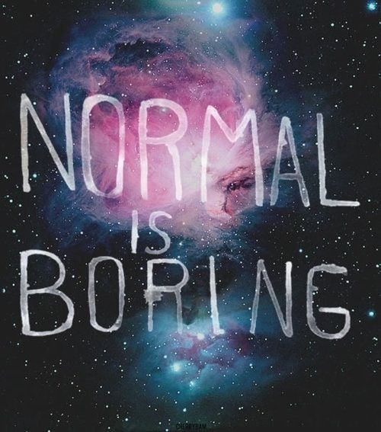
Why do we confide to these people?
Why do we regret not chasing our dreams?
Why don’t we reach for the stars anymore?
Why do we settle for the moon?
You should be going higher,
Don’t aspire to be normal,
Aspire to be abnormal,
Excel in something you love,
And in the end if you want to be normal be normal,
But at least you get to know,
You chased for your dreams,
You might not have made it but,
You tried and that’s all that matters.

