Float Your Boat Challenge
By: Jasmine Park
Group Members: Shelby, Nathan, Min
Science 10 Block C

Problem: To create a boat out of materials given (tinfoil, marshmallows, straws…) that can float and hold as many pennies.

Hypothesis: If buoyancy affects the boat, then the boat will hold the greatest quantity of pennies because it will be able to stay afloat.

Observations:

- Top of the boat, St. Georgie.

- Bottom of the boat.

- During the experiment, inside the water.
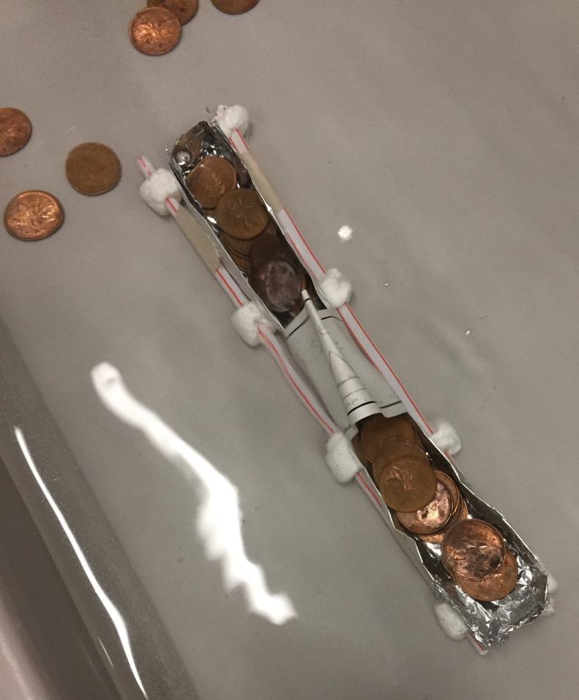

Results and Conclusions:
The boat held 33 pennies in total, more than I have expected it to.

The original thinking and reasoning behind the design was so that the tin foil supported the pennies and the straw and marshmallows would lift the rectangular-shaped boat full of pennies.

If the following challenge was repeated, to improve the boat design, the following changes would be made, such as making the base of the boat sturdier and higher walls because I found that when the pennies were inside the boat, the boat started to slant because the pennies were crowded on one side.

