Float Your Boat Challenge
By: Jared Lascano
Group Members: Jared, Emma, Dylan
Science 10 Block D

Problem: to make a boat that can carry a mass amount of pennies

Hypothesis: “IF” the buoyancy due to the marshmallow is spread around equally under the boat then the boat will hold the most amount because it will be the most balanced

Observations:
- Top view
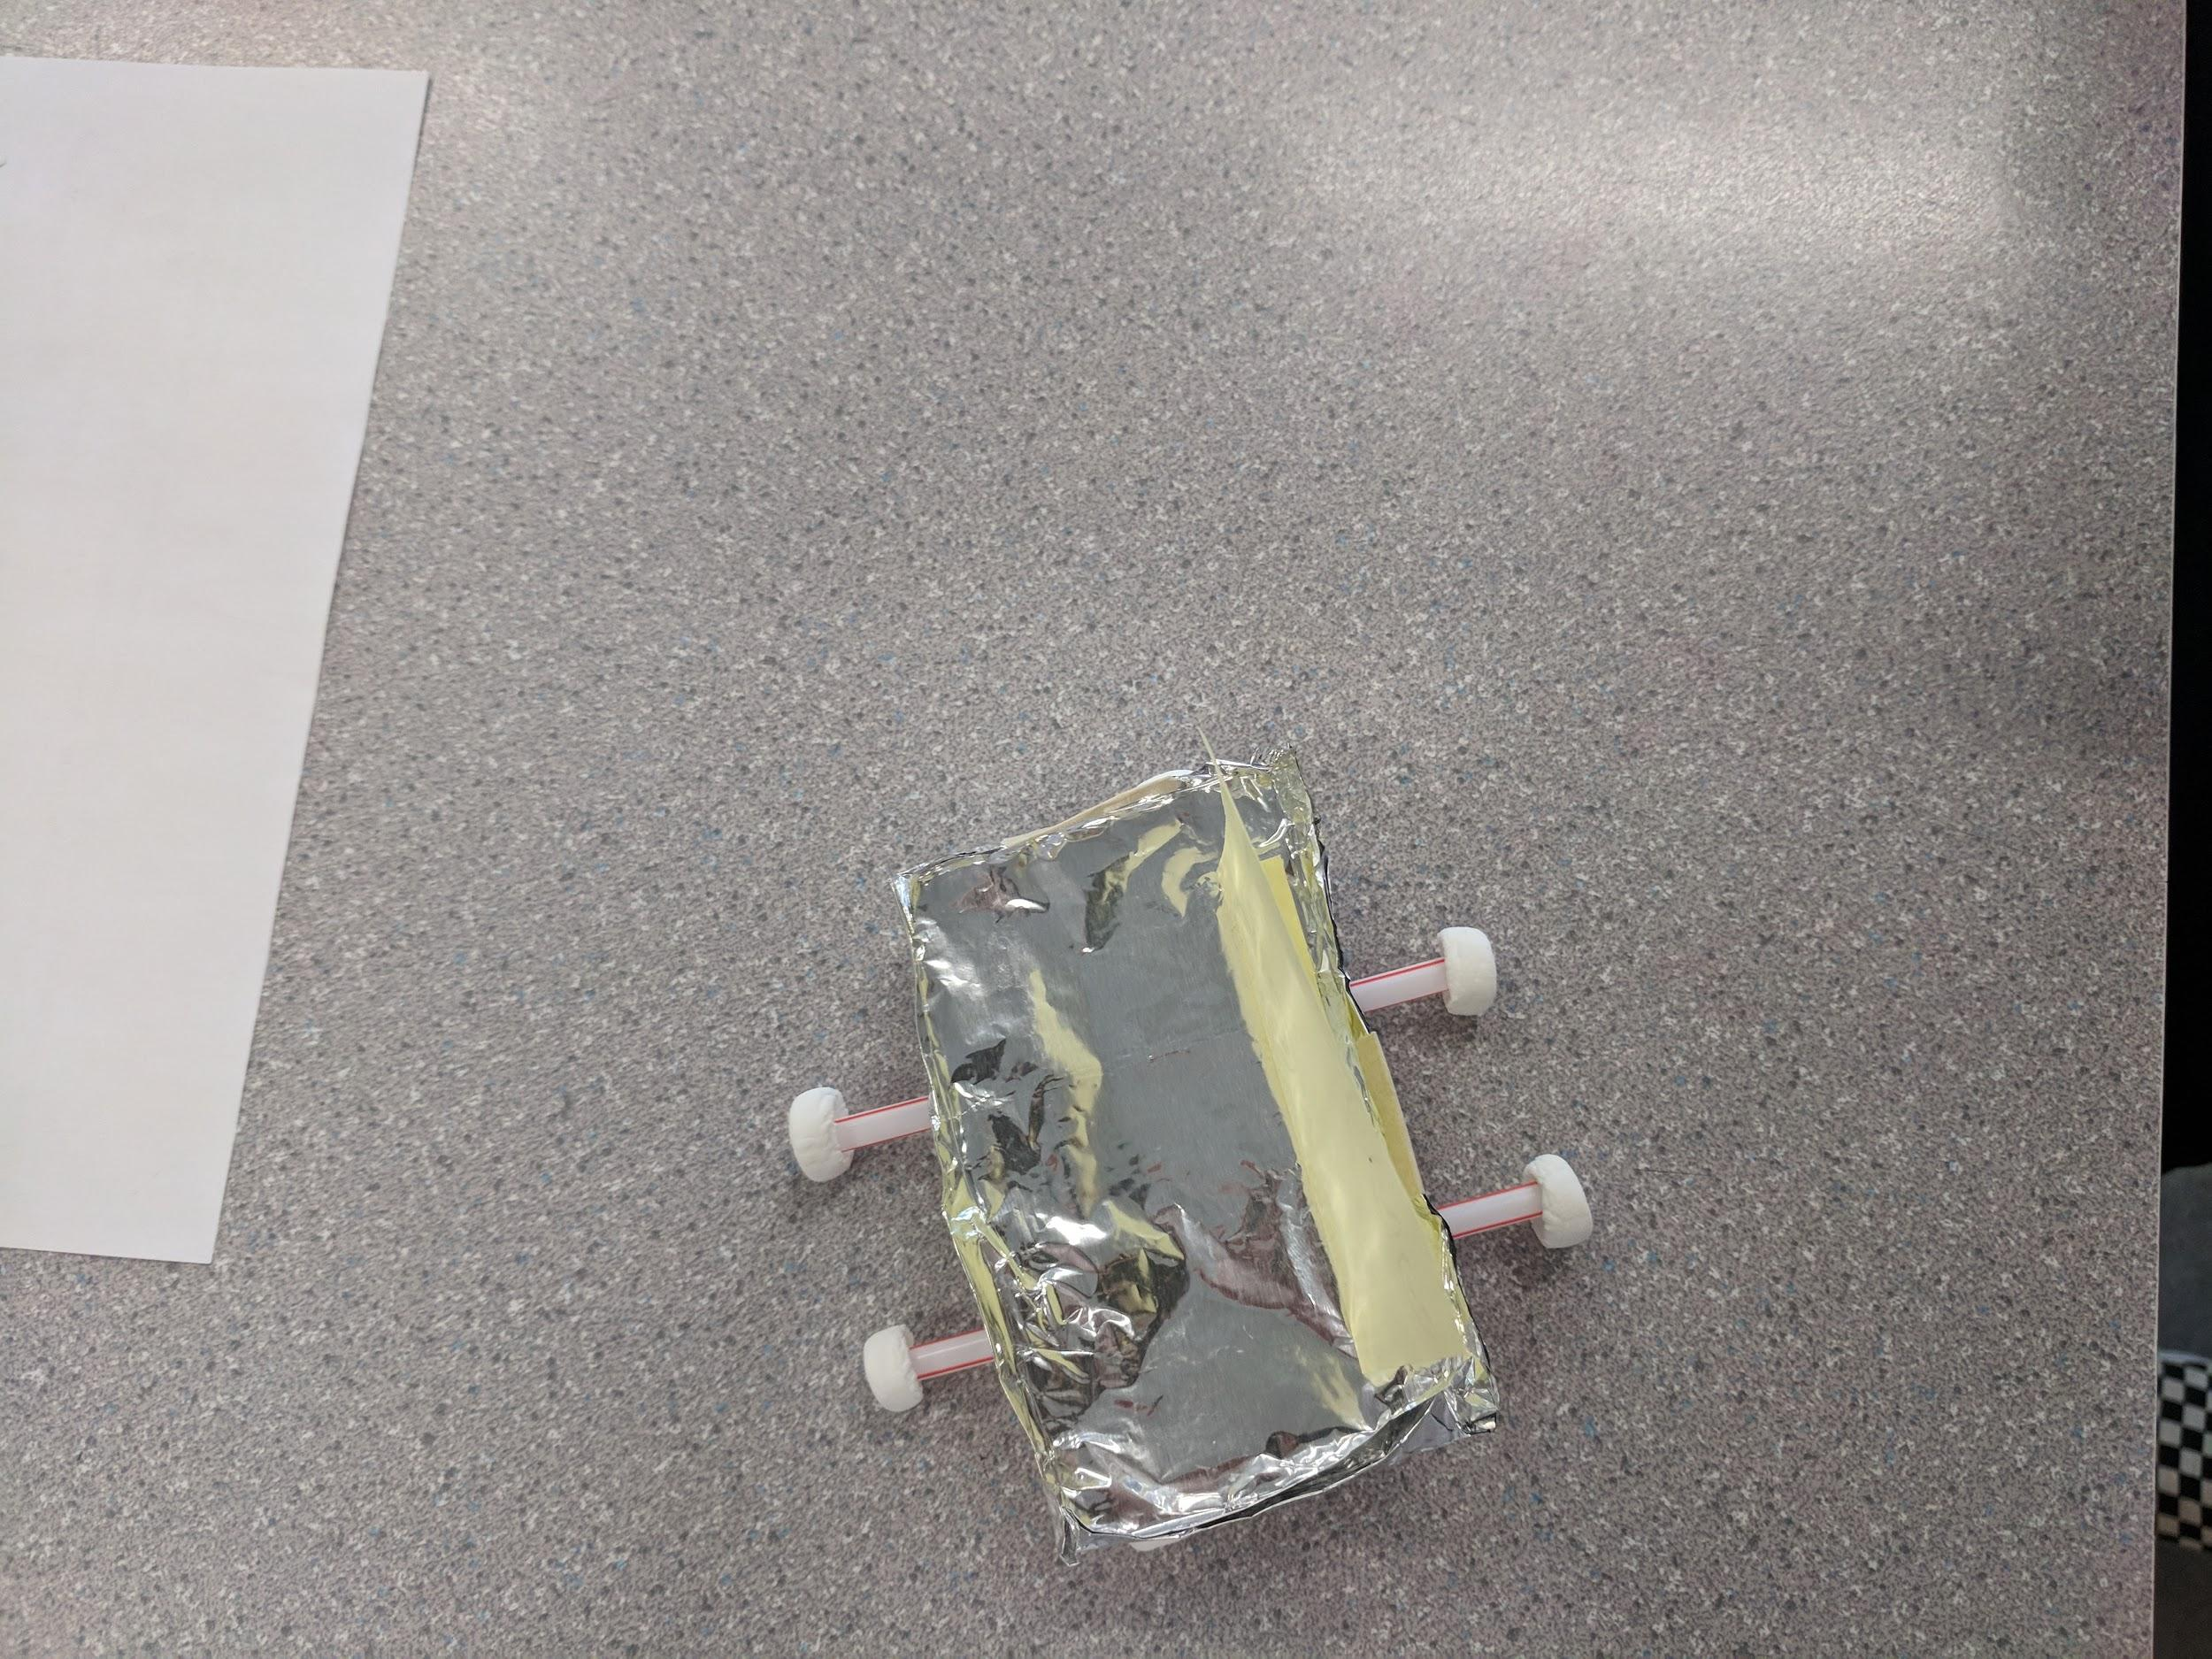
2. Bottom view
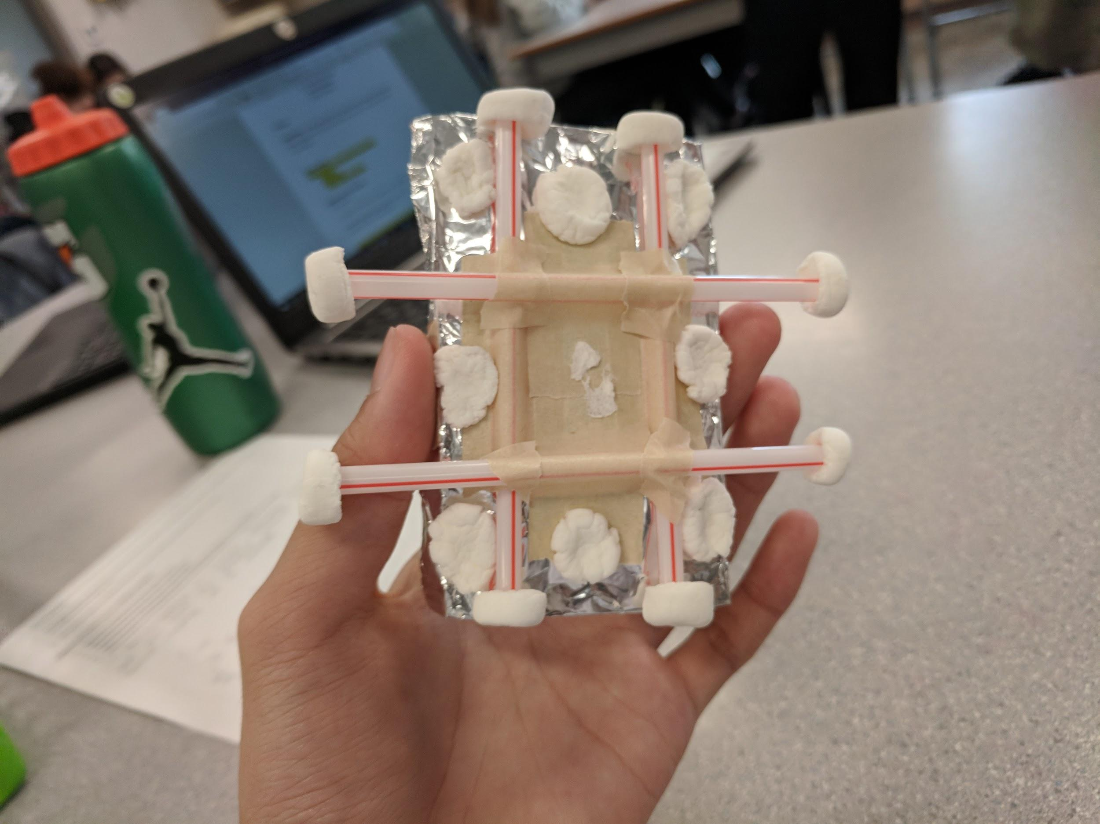
3. Picture of the boat in the water
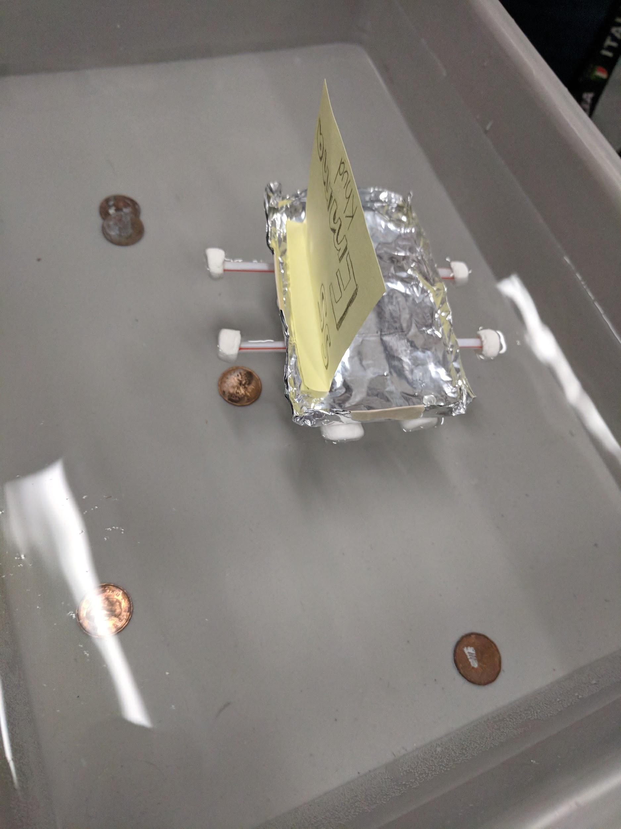

Results and Conclusions:
The boat held 19 pennies

The original thinking and reasoning behind the design was by making a tic tac toe shaped base, the weight would be spread out more evenly

If the following challenge was repeated, to improve the boat design, the following changes would be made. Make it more of a bowl shape, a little more dense, and to keep the marshmallow full shape.

