
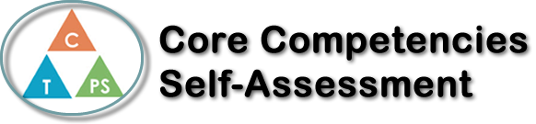
Name: Janna Grant | Date: 15th December 2017

  How does the artifact you selected demonstrate strengths & growth in the communication competency?  In what ways might you further develop your communication competency? | Self-Reflection  Describe how the artifact you selected shows your strengths & growth in specific core competencies. The prompt questions on the left - or other self-assessment activities you may have done - may guide your reflection process.  I chose the core competency Creative Thinking for my project on the book “un bouteille dans un mer de gaza.”  For the creative thinking process, I tried to think of some creative ideas based off the information about the characters I already knew. I then tried to further develop the relationships of the characters. To create a story, you also need to first establish a setting. By using my creative thinking, I wrote a bit of a background story to include all the necessary information for the story. After I had developed background, setting, and character, it was time to develop the main plot of the story. While creating a plot, I tried to think about what would make an interesting story, and that would keep the readers engaged. I also needed a point to the story. Why was I going to write it? What did I want to happen in the end? After I had planned the basic plot of the story, I started to write. At first, it seemed like I had just threw up all my ideas onto the page. Once I could make sense of everything I had written, I edited it so that my grammar was a lot clearer and then once I had edited, I reviewed it again. I then finished clarifying all my thoughts I started to write the ending. I concluded the story and resolved the conflict. I then once again reviewed my ideas and edited.


How does the artifact you selected demonstrate strengths & growth in the thinking competencies?

In what ways might you further develop your thinking competencies?


How does the artifact you selected demonstrate strengths & growth in the personal & social competencies?

In what ways might you further develop your personal & social competencies?

Publish Your Self Assessment
You will now attach and/or embed your self-assessment to the bottom of the blog post with the artifact you have chosen. You may choose to make this post private or public. After placing your artifact on a blog post, follow the instructions below.
- Categories - Self-Assessment
- Tags - Now tag your post using the tag that corresponds to the competency that you have written about. You can choose more than one. Please use lower case letters and be exact.
  - #creativethinkingcc
  - #communicationcc
  - #criticalthinkingcc
  - #socialresponsibilitycc
  - #personalidentitycc
  - #personalawarenesscc
- Use the Add Document button located at the top of your post page and embed your self-assessment at the bottom of your blog post.
- Publish

