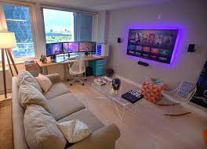
Page 1
- Use digital images (IN PICTURES ONLY) to create a collage illustrating the future lifestyle you’d like for yourself at 25-30 years old.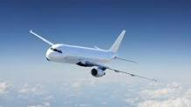
  - Include: type of transportation, type of house and where it’ll be, family/spouse, pets, travel, things you’ll do in your spare time, etc.
I will probably spend most of time with my family and then I will do my hobby in my spare time.
  - If there are items on the list above that you don’t want (family/pets/travel/etc.) then you don’t need to include them, but make sure you demonstrate all aspects you want in your future life.
I want a game room and travelling a lot in the future.
Page 2
- Summarize in a few sentences what your future lifestyle might be.
  - What type of things will you do? What will you do when you go out? I will probably star-up like setting up a company and then I will spend most of time with family, there are also many business trips happen
  - What will a typical day look like in your life?
It will be very busy
  - Overall, do you want to live a life of luxury, or regular every day living, or simple with no extras, or…?
Just regular day is enough for me

- List your career’s annual income.
10k

- List the price to purchase each item in your collage, or approximately what it would cost for it
  - Average cost of a wedding
25k
  - Average annual cost of a child
10k
  - Cost of a car/bike/annual transit pass depending on what you chose
8k
  - Etc.

