Chinese Food

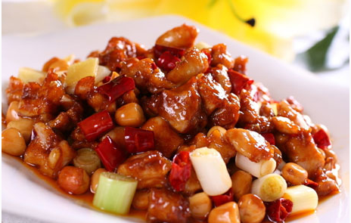
Kung Pao Chicken
Kung Pao Chicken, is a famous traditional Chinese and foreign dishes. Shandong cuisine, Sichuan cuisine, Guizhou dishes are included, raw materials, practices are different. [1] The origin of the dishes and Shandong cuisine in the sauce of chicken, and Guizhou cuisine Hu spicy Chicken, after the Qing Dynasty governor of Shandong, Sichuan Governor Ding Baozhen improved development, the formation of a new dish - Gong Bao Chicken, and spread so far, this dish has also been summarized as Beijing palace dishes [2]. After Kung Pao Chicken also spread abroad.
Kung Pao Chicken selected chicken-based material, accompanied by peanuts, cucumber, pepper and other accessories cooked. Red and not spicy, spicy and not fierce, spicy Sauvignon, crisp flesh. Because of its fresh imported spicy, fresh chicken with crisp peanuts.
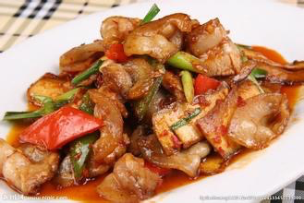
Twice - cooked pork
Pork is a pork cooked in Sichuan traditional dishes, belonging to Sichuan cuisine. Origin Sichuan rural areas [1]. Ancient times known as the oil explosion pot; Sichuan region can produce most of the family. Hui Guoru is characterized by: unique taste, color Hongliang, fat but not greasy, the entrance Luzhou. The so-called Hui Guo, is the meaning of cooking again. The role of twice-cooked pork in the Sichuan cuisine is very important. Twice-cooked pork has always been considered the first Sichuan, Sichuan of the incarnation, the inevitable mention of Sichuan-cooked pork. It is the color of flavor and taste, color seductive, is the next choice of food. Ingredients are different, in addition to garlic (garlic) can also use color pepper, onions, leeks, kettle, etc. to produce twice-cooked pork, each has its own recipe.
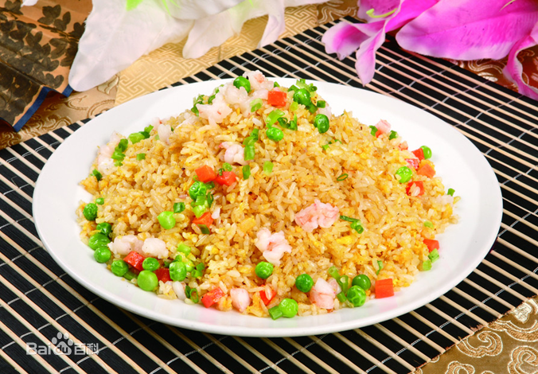
AYangzhou fried rice
Yangzhou fried rice, also known as Yangzhou egg fried rice, Jiangsu Yangzhou classic snacks. According to legend, from the Sui Dynasty, after the gradual innovation on behalf of the chef, combined with Huaiyang characteristics, developed.
Yangzhou fried rice in a broad sense, many varieties, "gold wrapped silver", "assorted eggs fried rice" and "fried rice vegetables" and so on. Among them, assorted eggs fried rice is the most typical varieties. Then fried rice, and finally fried eggs and other ingredients will be poured into the other half of the fry, stir well after the three-point out of the sung out, and then stir-fried rice, The second on the plate, and then the remaining ingredients and the pot of rice stir well, cover the dish in the fried rice.

