Exploring quadratic functions (7.1)
Follow the instructions laid out in this worksheet and post your answers in a blog post. Use www.desmos.com to answer the questions below.
Due: Wednesday Sept 26th
Title: Exploring quadratic functions
Categorize: Math 11
Tag: quadratics, Pahlevanlu
- Find and write the definition of a quadratic function in words you understand. (use your textbook, google, etc)
A quadratic function is one of the form f(x) = ax² + bx + c, where a, b, and c are numbers with a not equal to zero.

- Give an example of a quadratic function and give an example of a function that is NOT a quadratic.
Y or f(x)=6x²-2x+15 is an example of quadratic function.
Y = 4x +4. this Is not an example of a quadratic function.

- Go to desmos.com and type in the following function: $y=ax^{2}+bx+c$
  - Desmos will give you the option of adding “sliders” for $a, b, c$ or all. Click all. This will allow you to change the values of $a, b, c$ to see how the graph changes.
  - Start with slider values $a=1, b=0, c=0$. Describe any symmetry you notice.
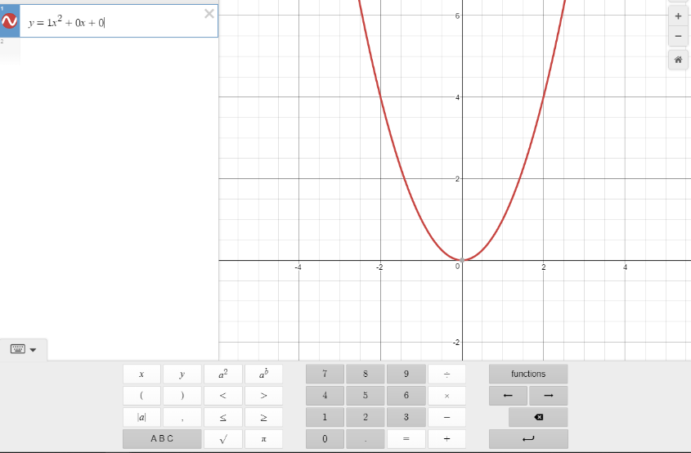
- Keep b = c = 0. Change the value of $a$:
  - $a<2$
    - Does the graph open up or open down?
    - Does the graph have a maximum point or minimum point?
The graph has a minimum point of 0
  - $a>-1$
    - Does the graph open up or open down?
    - Does the graph have a maximum point or minimum point?
The graph has a maximum point of 0

  - $-1<a<1$
    - Is the graph narrow or wide?
  - $a>1 or a<-1$
    - Is the graph narrow or wide
- We call the maximum or minimum point $(x,y)$ of a quadratic function the vertex. Complete the following statements:
  - When $a$ is (positive/negative), the vertex is a (maximum/minimum)
  - When $a$ is (positive/negative), the vertex is a (maximum/minimum)

- Let $a=1$ and $b=0$constant. Use the slider to change the value of $c.$Describe how the graph changes as $c$changes.

When the C point is changes where on the y axis the line starts or where the maximum or minimum point is

Roots are the solutions to the quadratic equation. The roots are found by looking at where the curve crosses the x axis (x-intercepts).
Adjust the sliders for a, b and c so you can get a curve that just touches the x axis (y=0).

Equation: y=2x^2+4x+0

This quadratic equation has ONE solution.

Adjust the sliders so you can get the roots of 0 and -1

Equation: y=1x^2+0x+-1

This quadratic equation has TWO solutions.

Adjust the sliders so that the curve does NOT cross the x-axis.

Equation: y=-1x^2+0x+-1

When the curve does NOT cross the x-axis, there are NO REAL solutions for this equation.

