Classifying Reactions Comic

1. Synthesis: (A + B -> AB)

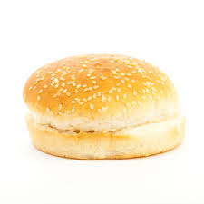 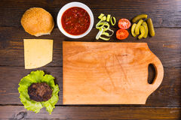 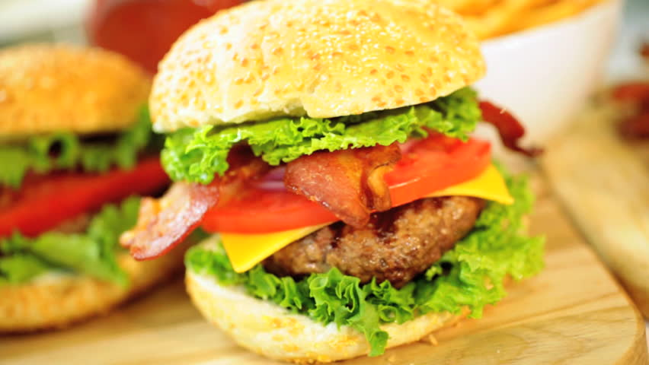

->

+

4P + 8O2 -> 2P2O8

1. Decomposition: (AB -> A + B)

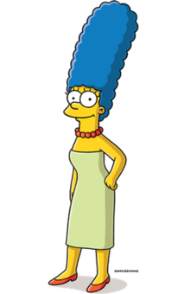 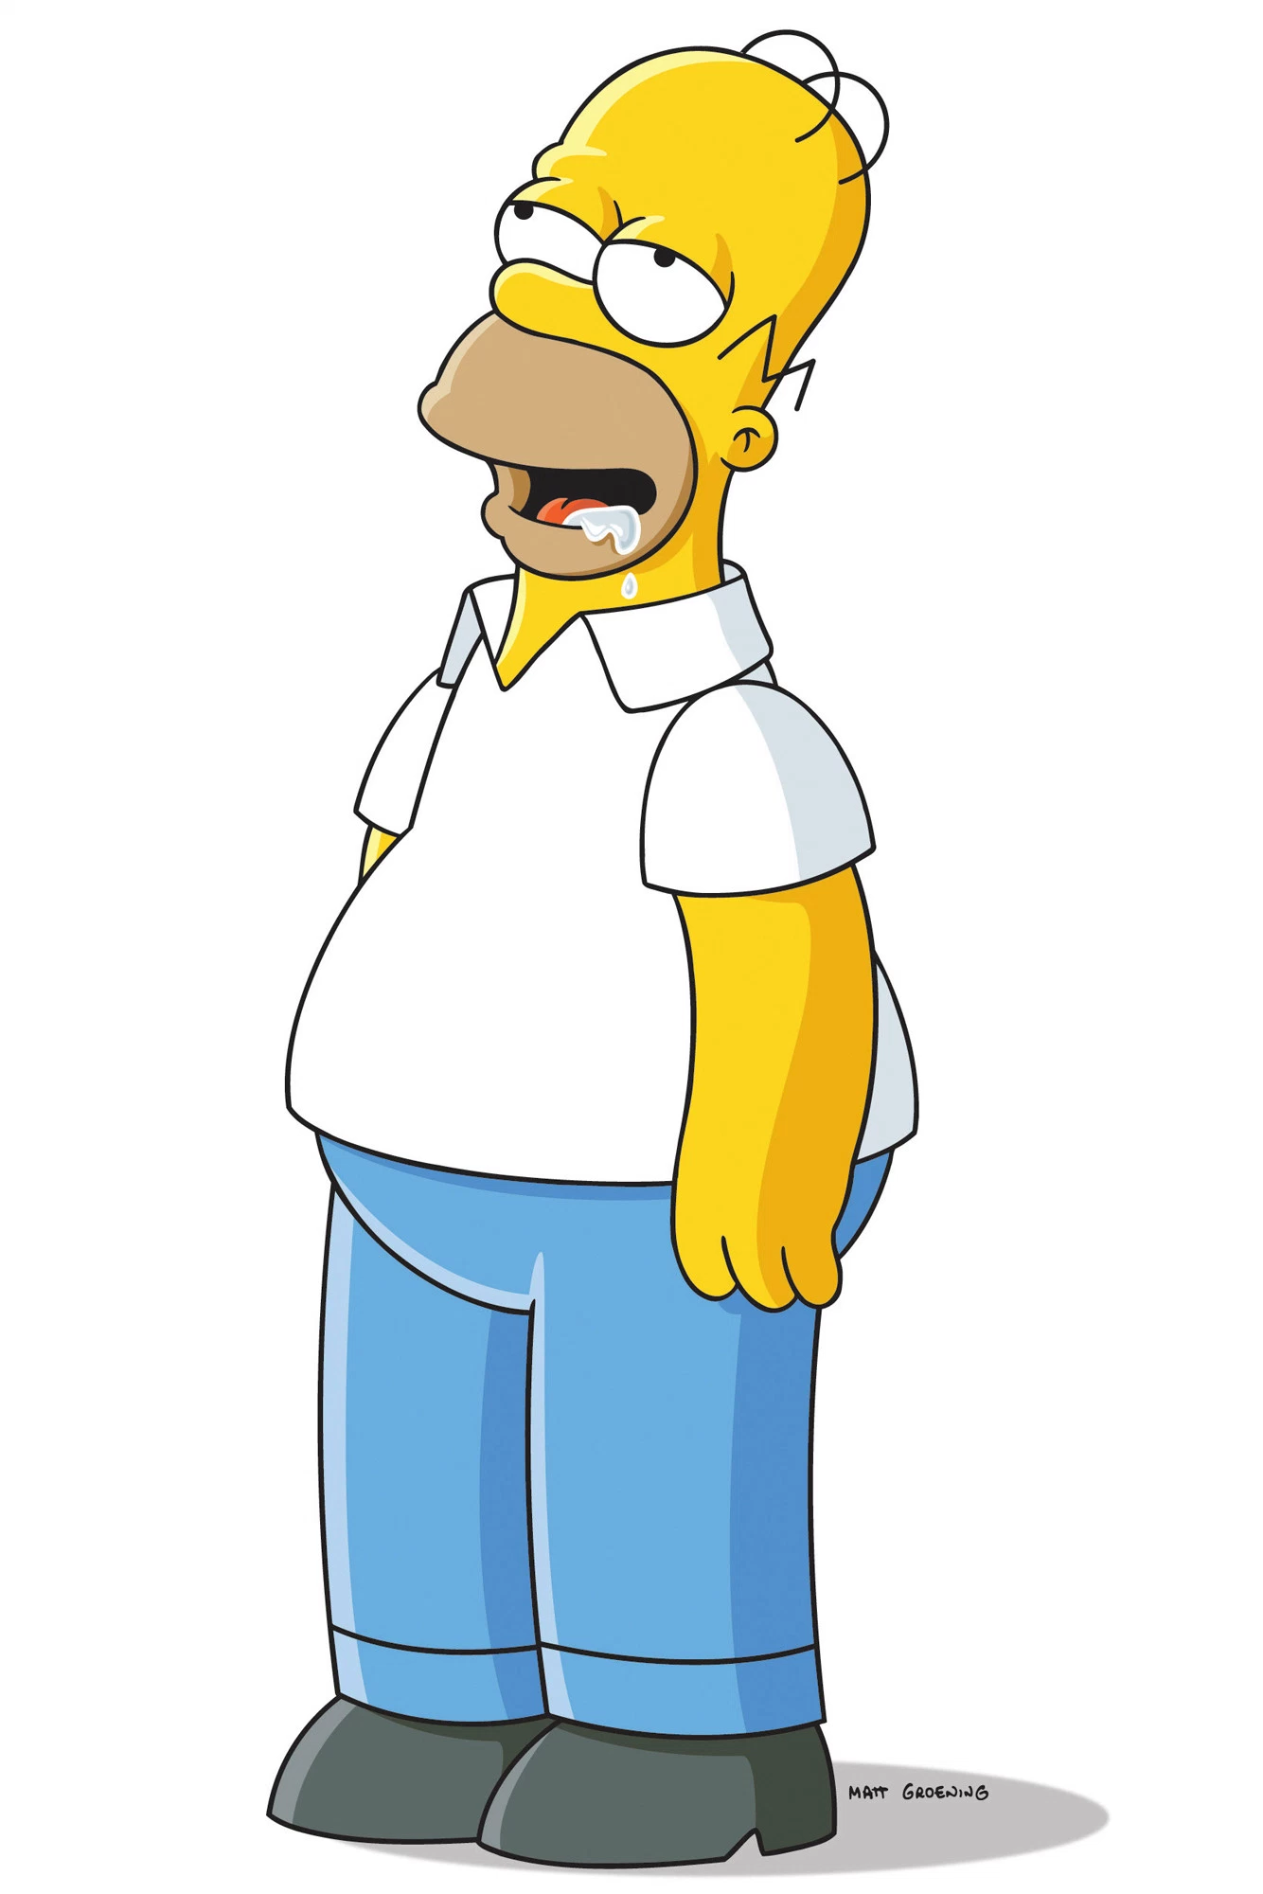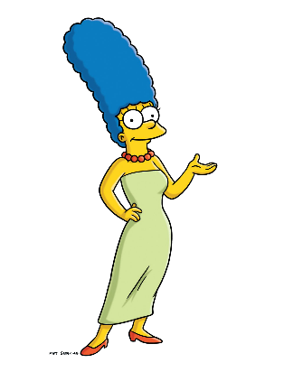

+

->

2NO2 -> 2O2 + N2

1. Single Replacement (AB + C -> AC + B)

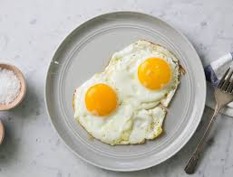 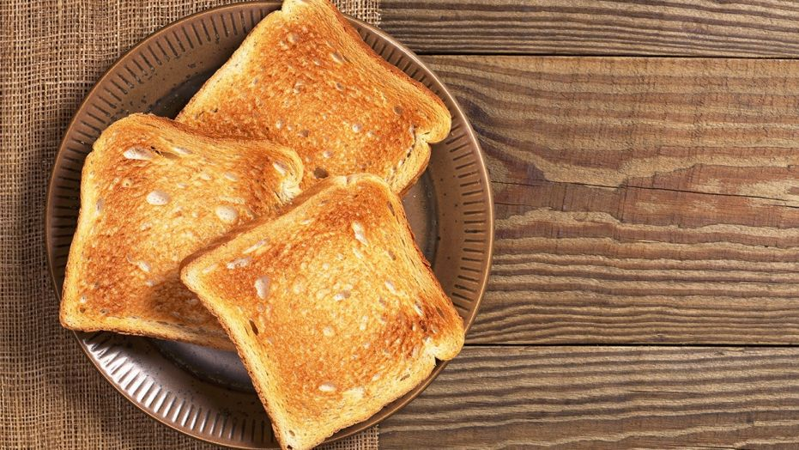 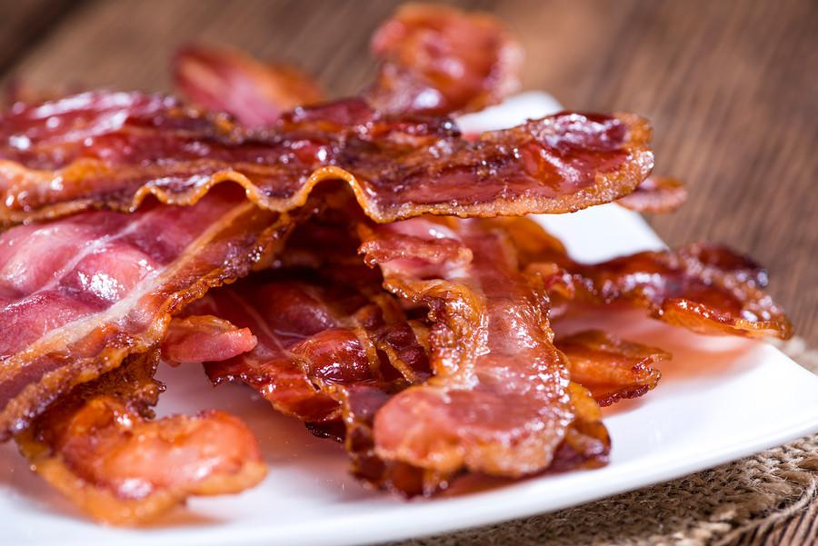

->

+



+

C6H12 + 12O2 -> 3C2 + 12HO2

1. Double Replacement (AB + CD -> AD + BC)



+

->

+

2MgCl2 + 2Li2CO3 -> 2MgCO3 + 4LiCl