**Float Your Boat Challenge**

By: Isaac Code

Group Members: Flora, Maebel, Sabrina

Science 10 Block D

**Problem: To make the boat hold as many pennies as it can.**

**Hypothesis: If the structure is balanced then the boat will hold the greatest quantity of pennies because it will have a strong structure.**

**Observations:**

Original design

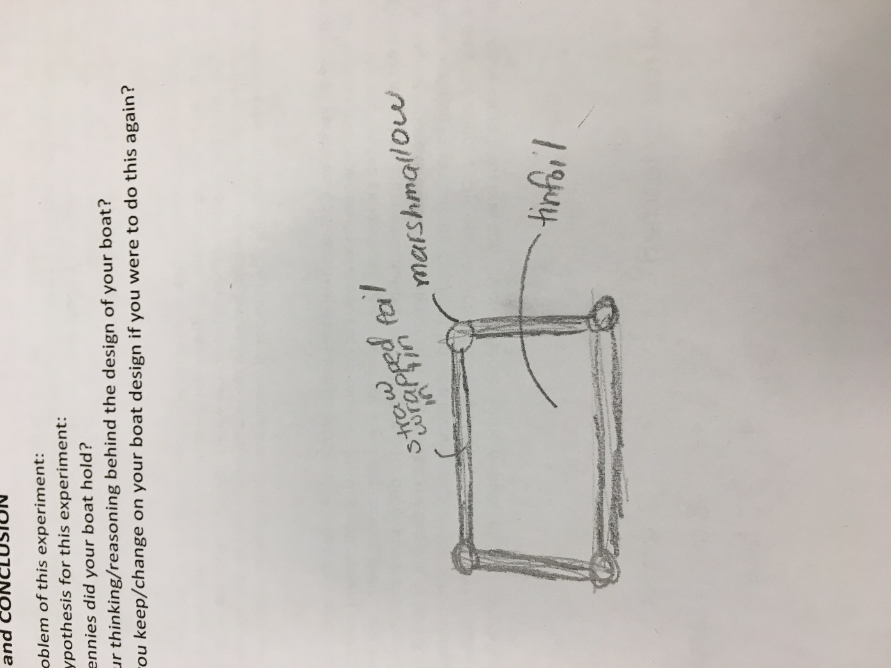

Top View

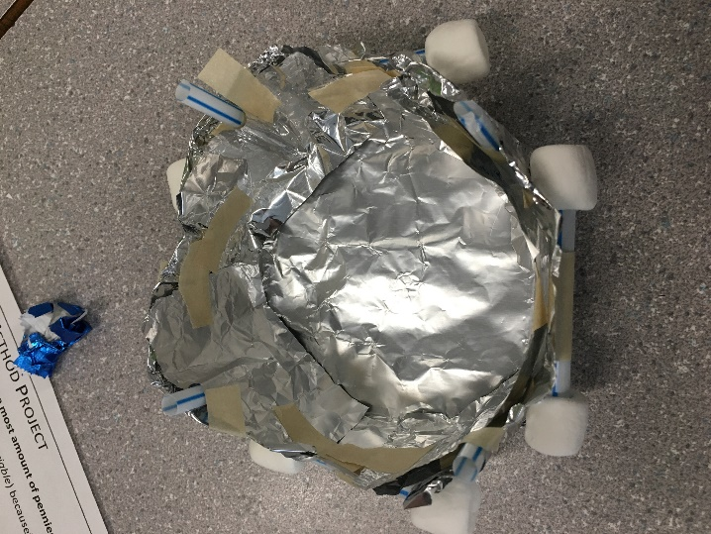

Bottom View

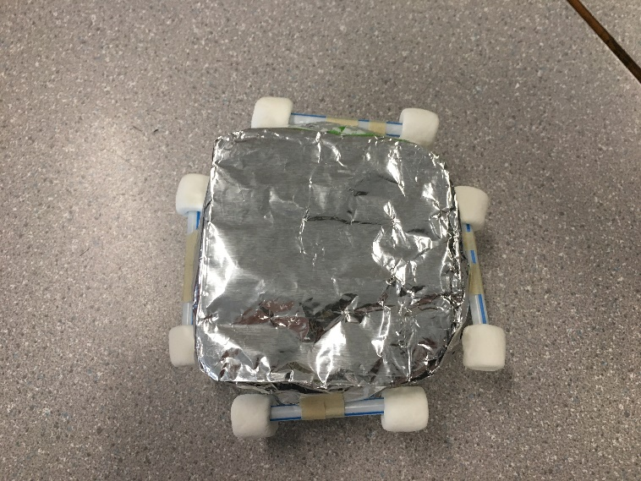

In the water

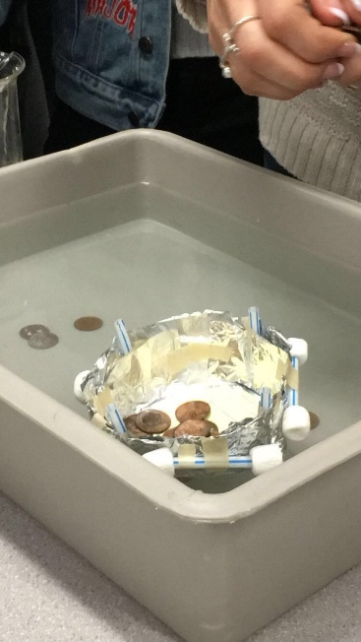

**Results and Conclusions:**

The boat held 101 pennies

The original thinking and reasoning behind the design was that there would be a compartment for the pennies semi deep made out of the tin foil and the straws and marshmallows will be the main floating power at the top so it would be balanced.

If the following challenge was repeated, to improve the boat design, the following changes would be made toward the structure of the tin foil, because the sheet was a very thin, it would have been better if there was a double layer of tin foil. As well as the places where the tape, and the marshmallows / straws where, it was not balanced.

Upload this document to your Edublog and Tag your post “floatyourboatdurandsc10blk_” add your block letter “C or D”