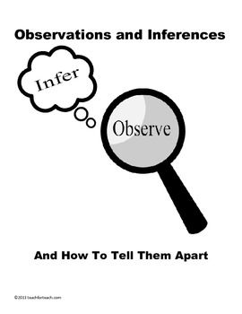**Observations and Inferences**

Science 10 Name: BLK:

|  |  |  |  |
| --- | --- | --- | --- |
| **OBJECT** | **OBSERVATIONS**  **Words that describe the object** | **INFERENCES**  **Ie: Where might the object come from? Possible uses? Etc.** | **QUESTIONS YOU HAVE ABOUT THE OBJECT** |
| Image | Smells fabric softener  In a peetree dish  Blueish green  Liquidly  Glossy  When tipped it turns darker | Smells like fabric  The color is due to dye  Can you use it in clothes?  Could be laundry cleaner because of smell | Where is the liquid from?  What is the use of it  Why is it blue  What are the ingredients  Is it edible |
|  | White  Bone  Looks like a paddle  Feels Course  Hard  light | Could be Bone from dinosaur  Could be a fin  When nocked it sounds hollow so it could be hollow inside.  It is a type of bone  From a big animal  Could be million years old | How old is it? what dinosaur is it from  What animal is this from  What part of the animal is this |
|  | Red and black  Multi purpose tool  Key chain  Possible weapon  Seat belt cutter | Could be used to break glass  Multi purpose tool  Used on a key chain  Used to punch holes  Can be used to attack on a back pack in survival situation | What does it really do  What can you cut with this  What other uses are there  Who can use it  Where can you buy this  Why was this object made |
|  | Sandy color  Sharpe teeth  Lots of holes  Deep areas for nose and eyes  Long skull | Possible animal skull  Millions of years old  Brain skull is cut out  Could be used for decoration  Used from scientists to obverse | How old is it  What animal is it from  How old is it  How did people find it  What is it used for now |

|  |  |  |  |  |  |
| --- | --- | --- | --- | --- | --- |
| **Observations/Inferences Assignment Assessment**  Name: _____________________  **Ex: Excellent VG: Very Good G: Good S: Satisfactory IN: Improvement is needed** | | | | | |
| **Criteria** | **IN** | **S** | **G** | **VG** | **Ex** |
| The following is included   * All 4 Images included |  |  | | |  |
| Observations:   * A minimum of 5 **detailed** observations made |  |  |  |  |  |
| Inferences:   * **Thoughtful and logical** inferences made |  |  |  |  |  |
| Questions:   * 2 thoughtful and logical questions made |  |  |  |  |  |
| * Spelling/grammar |  |  |  |  |  |
| * Assignment was completed on time |  |  | | |  |

/10