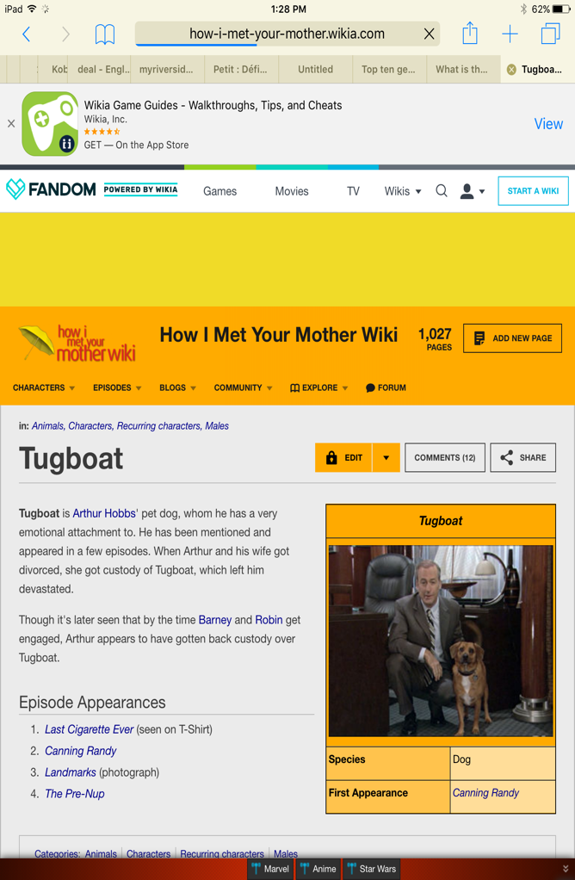
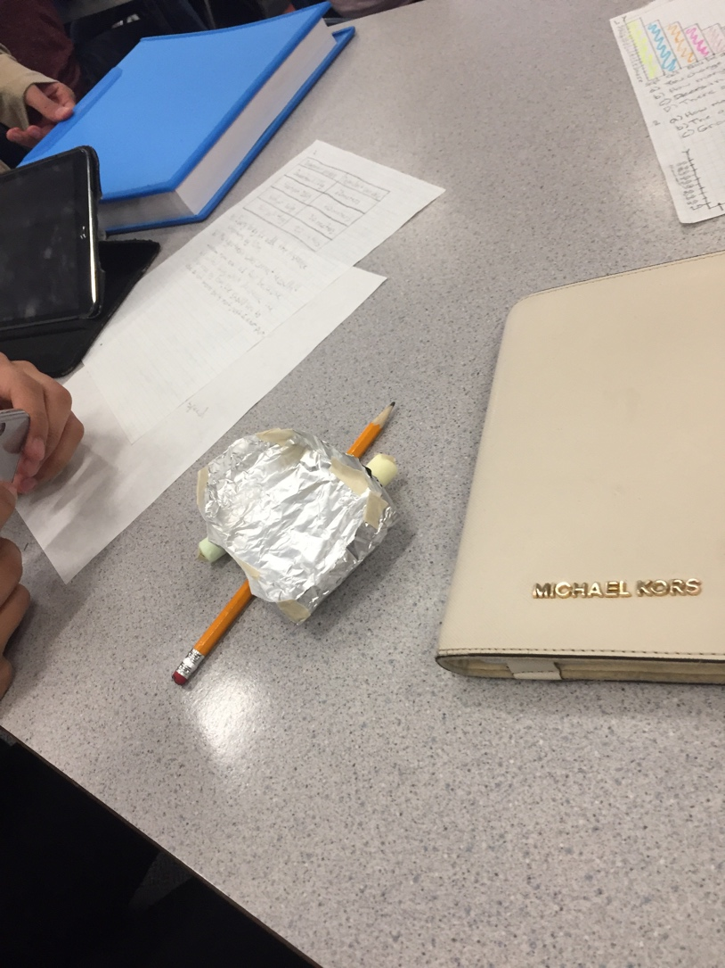
Hypothesis:
If we make the boat have floaters on the side using marshmallows and double layer it to have air to keep it up then it will hold around 50 penny’s because of how good the design is.

Observations:
It held 51+ pennies, was double layer folded and had 2 marshmallow floaters

Overview: We had a few minutes to make a boat using a piece of tinfoil, 2 toothpicks and 2 mini marshmallows.

Conclusion: Our boat (Tugboat) ended up holding 51 penny’s before we dropped a handful to not see precisely how many penny’s our boat could’ve held. My hypothesis was correct since I said it would hold around 50 penny’s. The placement of the penny’s and dropping a handful at the end we’re errors that could’ve changed the results. I feel we could’ve had the walls slightly higher which would allow less water in and I think the same around of pennys

