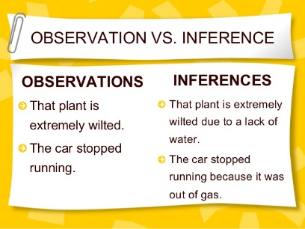
Group Names: Science 10 BLK:
OBSERVATIONS VS. INFERENCES

OBJECT LETTER & UPLOADED PICTURE | OBSERVATIONS | INFERENCES
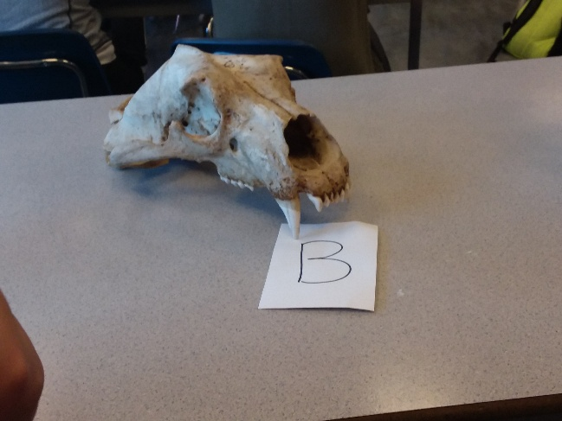 | - Pointy teeth  - Large nose  - Chipped tooth  - About a foot long  - Big eye sockets  - Bump on top of head  - Bone head  - Large cheek bones. | Because of the Pointy teeth, the large nose and how big the eye sockets are I believe this could either be a canine of some kind.  I also believe this could be a large cat. Like a lion or tiger from the wide cheeks and the fangs.
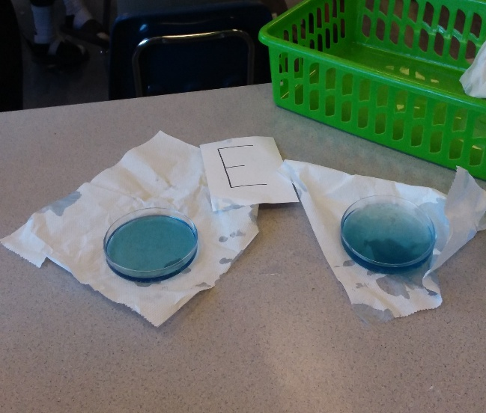 | - Blue liquid  - Sticky  - Smells like laundry detergent  - More in one section it gets darker | By the smell, color, sticky feeling and that it’s not moving I believe it is laundry detergent.
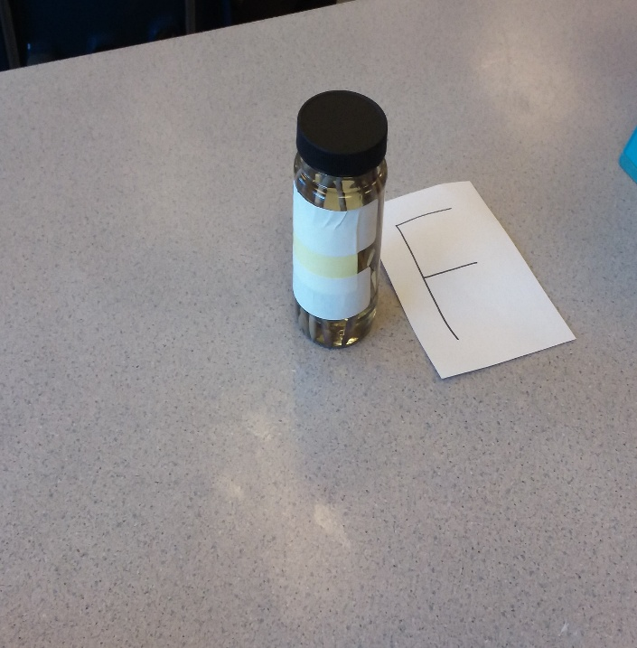 | - Liquid jar filled with worm looking things.  - Grayish color of the wormy things.  - Vinegar and moldy smell.  - Color of liquid is yellow. | By the look of the object it looks like worms. The moldy smell (which I can’t get out of my nose. Even from wafting) is probably an indication of the worms being dead. Also the yellow color of the liquid could be of the decomposition of the worms over time.
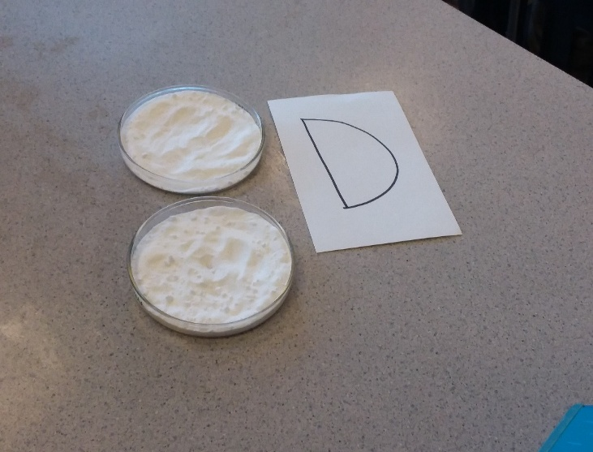 | - White powder  - Crumbly  - Feels like sand  - Not much of a smell.  - Compacted | By my observations I think that this substance is baking soda. By the powder being white and the Compacted look you can tell. I also know because I have a history in cooking (dad’s a chef). The smell can’t really help unless you have an idea of what baking soda smells like. It could however be backing powder by the smell as well. But I believe from the look and the way it is that it’s baking soda.

