SSEP effect on Bacterial Growth and its Resistance to Antibiotics

Bacteria: staphylococcus intermedius
Anti-biotic: ciprofloxacin, (witch is known at as a good killer of this bacteria)
B)
The Purpose of experiment was to monitor the effect of microgravity on the growth of bacteria and how it resists an antibiotic that was originally used to kill the bacteria.
when using FME type 3, will be able to control when each "ingredient" is added to the experiment.

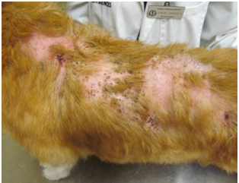
The bacteria used in this experiment is called staphylococcus intermedius, which is a very common bacterium that can cause multiple harmful infections
Staphylococcus intermedius can be found in pigeons, dogs, mink, and horses
The Bacteria grown is space is more virulent.
This is the affect it has on a dog
http://www.dermatologyforanimals.com/resistant-staph-infections-in-animals/

The antibiotic used in this experiment was called ciprofloxacin, which is said to be a good killer of this specific bacteria
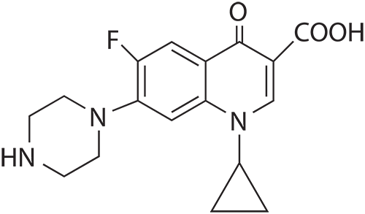
Ciprofloxacin is an antibiotic used to treat a lot of bacterial infections including, bone and joint infections, intra abdominal infections, certain type of infectious diarrhea, respiratory tract infections, skin infections, typhoid fever, and urinary tract infections, among others and Can be taken in tablets.
Structure of ciprofloxacin
http://www.lktlabs.com/products/Ciprofloxacin-327-8.html
Questions 1a, 1c, 1d, 2
2. I think this team won because they tested on a bacterium in space, something very creative and could benefit the space men up there, if this theory effects every bacterium.

1.
A) who -grade 10 11 at valley center Kansas high school
Co-principal garret chandler, Wesley crow, and Cole kink hammer

what -they tested the effect of and anti bacteria on a bacterium in space to see if the effect is differed
from where -at valley center Kansas high school
when -February 1st 2013
why -to test if it would be more effective or less effective, it may not be much but all new information is valued
c) The difference between a control group and an experimental group is the experimental group is exposed to the conditions of the experiment and the other is not. Experimental group minimum fully engaged is 600, control group minimum of student team proposals 120
D) the effects of micro gravity on bacterial growth
In space more layers of bacteria are exposed to
nutrients causing more reproduction. In micro
gravity the cells have no density enabling greater
spatial freedom for replication and nutrition out take
which increase the amount of bacteria that is produced? The bacterial
growth rate increases rapidly in space.

.

The bacterial growth has a shorter time adjusting to the environment.
Staphylococcus it's originally come's from the nasal cavity of a dog pigeon foxes and horses. it's a gram positive bacteria which means it has a thick cell wall of protein called peptidoglycan. Beneath the microscope they are round and form in clusters. staphylococcus intermedius is one in many 40 species of its type. It normally lives on the skin and in the mucus of humans and other organisms. staphylococcus can cause one in many diseases in the human and animals body.

