SMART GOAL: Personal
(Specific, Measurable, Achievable, Realistic, Timely)

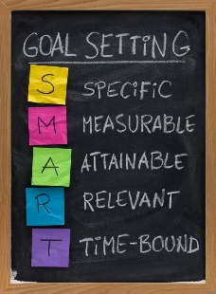
GOAL STATEMENT:
I will save 500 dollars a month and save next 3 months to buy a laptop. So during those three months I will eat at home usually, and don’t often having dinner outside.

WHAT DO I NEED TO REACH THIS GOAL? (The steps you
must take in order, and the date you wish the step to be
completed by.)

I need to save 500 dollars a month, put 500cad into saving account. on the usual day, don’t buy snake or drink at school. Try to not spend money on school day. On the weekend can going out, but try to eat at home.

HOW ARE YOU GOING TO MEASURE THE PROGRESS TOWARDS
YOUR GOAL
Check my online bank account every week and see how much you can spend left, and check every months if the money is more than last months.

OBSTACLES YOU MIGHT SOLUTIONS
FACE
- let parents know and use their card to buy it.
- Don’t going out then
- Have conversation with parents. And see if they can pay for me.
- Something I have to buy, such as books and daily necessities.
- Sometime spent more money than your thought
- The accident you don’t know it will happen, such as you broke something and you have to pay for it.

WHO ARE YOU GOING TO SHARE YOUR GOAL WITH?
I am going to share my goal with my friends and my brother, because they will know if you have a goal, nothing can’t stop you to getting it.

HOW WILL YOU CELEBRATE YOUR GOAL?
I will go out for dinner when I got my goal, because the goal I haven’t went out to eat for three months.

NEVER GIVE UP!

