**SMART GOAL: Education/Career**

(Specific, Measurable, Achievable, Realistic, Timely)

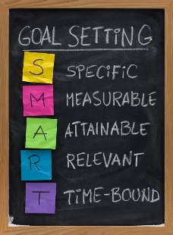 **GOAL STATEMENT:**

My goal is to graduate and go to a good university. Next two or three years I will study hard, try to reading more book and learning more knowledge in every school. Doing homework when before I go out or watch TV.

**WHAT DO I NEED TO REACH THIS GOAL? (The steps you**

**must take in order, and the date you wish the step to be**

**completed by.)**

In class, listen to teacher and do every work in class and stay focus in class. At home, do the homework before I doing other staff. In the weekend, doing homework first, and then doing other staff or handout with friend. If don’t know how to do the questions or don’t understand in the class, ask for help. At grade 11 or grade 12, try to read more book and learning more knowledge. Also put away the playing heart, try to focus more on learning. I hope the deadline is before 2020s.

**HOW ARE YOU GOING TO MEASURE THE PROGRESS TOWARDS**

**YOUR GOAL?**

Do exams every half year, and the level is more difficult than first half year. And see am I doing correctly in the exams and how much knowledge I mastered.

**OBSTACLES YOU MIGHT SOLUTIONS**

**FACE**

1. Find the problem why am I fail, and retake the courses, then try hard.
2. Ask teacher, or classmates for help or get a tutor.
3. Set a time schedule, and work on it.
4. Ask friends who speak the same language and had learn this course for help.
5. May failed some courses.
6. May don’t understand some part of questions.
7. Will be lazy sometimes
8. Get obstacles of language.

**WHO ARE YOU GOING TO SHARE YOUR GOAL WITH?**

I am going to share with my family, let them know I graduate and they will be happy. Also I am gong to share with my friends, hope they can graduate at same time with me.

**HOW WILL YOU CELEBRATE YOUR GOAL?**

I hope I can go travel with my brother or parents, and having a wonderful time with them. The reason why is because we did not have a family time for a long time.

**NEVER GIVE UP!**