Classifying Reaction Comic

- Synthesis (Combination) Reactions
A+B=AB
Unbalance: P4+ O2= P2 O3
Balance: P4+ 3 O2= 2P2 O3

+=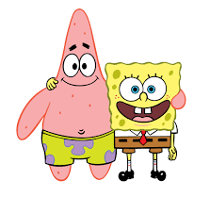

B. Decomposition Reaction
AB= A+B
Unbalance: NO2= O2+ N2
Balance: 2 NO2= 2 O2+ N2
= +

- Single Replacement
A+BC= B+AC
Unbalance: Pb + H3 PO4= H2+ Pb3(PO4)2
Balance: 6 Pb + 4 H3 PO4= 6 H2+ 2Pb3(PO4)2

+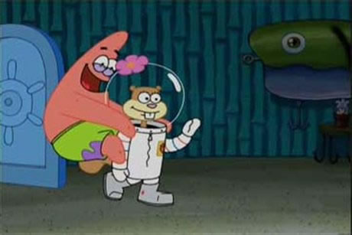= +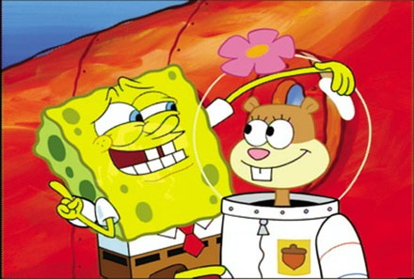

- Double Replacement Reaction
AB+CD= AD+ CB
Unbalance: Mg Cl2 + Li2 CO3 = Mg CO3+ Li Cl
Balance: Mg Cl2+ Li2 CO3= Mg CO3+ 2Li Cl



