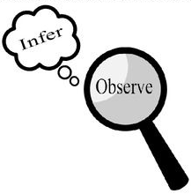
Observations and Inferences
Science 10 Name: Flora Salimi BLK: D

OBJECT | OBSERVATIONS  Words that describe the object | INFERENCES  Ie: Where might the object come from? Possible uses? Etc. | QUESTIONS YOU HAVE ABOUT THE OBJECT
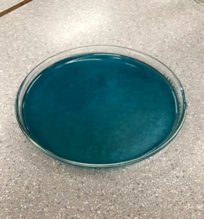 | - It’s turquoise/shade of blue  - Liquid  - Smells like fabric softener, or some cleaning agent  - In a Petri dish  - It’s not too thick  Glossy | - It could be detergent because of smell  - The color is due to dye  - Chemicals were used to create this liquid, based on the smell and artificial coloring  - It becomes more pigmented and darker when tipped to the side | - Where did the liquid come from?  - What is the use of color?  - Why was it made?  - What the ingredients?  - Will I die from consuming this liquid?  Is this liquid dangerous/poisonous?
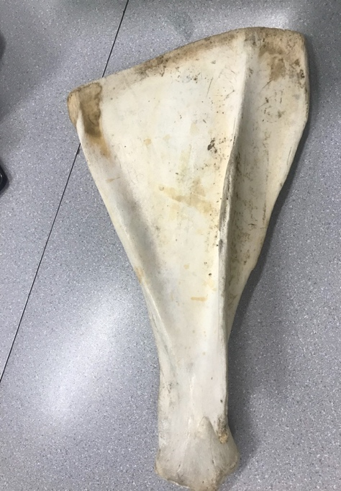 | - Sandy color or off-white  - Hollow sounding when hit  - Looks like a paddle  - Coarse in some areas and smooth in others  - Feels like plastic | - It could be a fin of fish  - Could use as a weapon  - Belong to large animal  - Could bee use as a paddle  - Could be very old  - A possible blood smear on the back  - Color could be from expose to oxygen or sun  - A type of bone | - What animal it comes from?  - What part of animal is that for?  - How old is it?  - What could it be used for?  - Where did this come from?
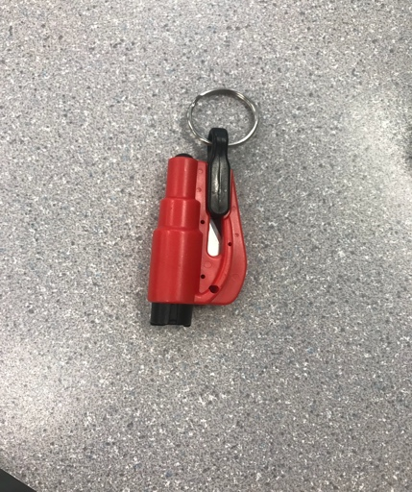 | - It's black and red  - Sharp and small blade inside  - It’s hard  - Made out of plastic  - It's smooth  - There is a black button on the other end  - A ring on the end | - Can be attach to something: bag or coat  - Use to cut or break something  - It's dangerous  - Multipurpose tool | - What other ways it can't his tool be used?  - Where can we buy this from?  - Why was this object made?
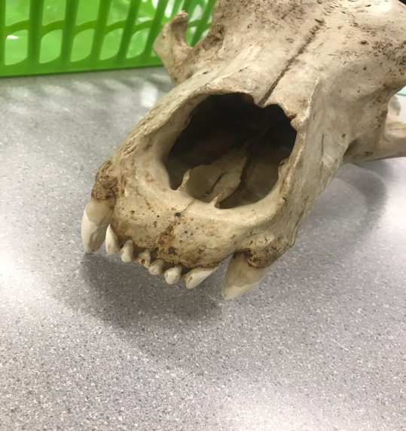  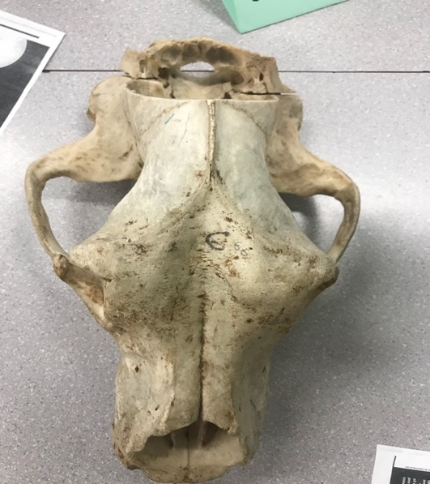 | - It has lots of holes  - Sand-color to beige  - Sharp and big teeth  - Long but not narrow skull  - A big animal with big a head  - Deep craves for eyes and nose | - The hole at the back of head is where the brain could have been stored  - Belongs to an animal  - Dark spots make skull look old  - It could be use for decor | -What kind of animal is that skull for?  - How old is it?  - What is it use for ?  - Why the skull slightly discolored?

Observations/Inferences Assignment Assessment
Name: _____________________
Ex: Excellent VG: Very Good G: Good S: Satisfactory IN: Improvement is needed
Criteria | IN | S | G | VG | Ex
The following is included
- All 4 Images included
Observations:
- A minimum of 5 detailed observations made
Inferences:
- Thoughtful and logical inferences made
Questions:
- 2 thoughtful and logical questions made
- Spelling/grammar
- Assignment was completed on time
/10

