Float Your Boat Challenge
By: Flora Salimi
Group Members: Isaac, Maebel, Sabrina
Science 10 Block: D

Problem: To be make our boat that can hold the most pennies, out of the whole class.

Hypothesis: If the structure is balanced then the boat will hold the greatest quantity of pennies because it has a strong base.
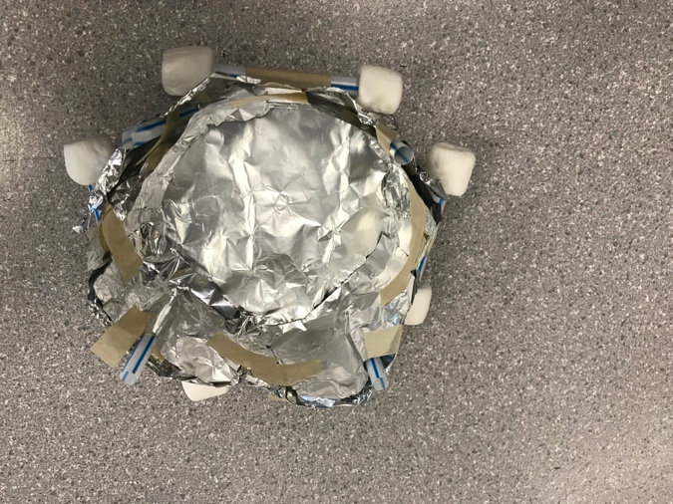
Observations:
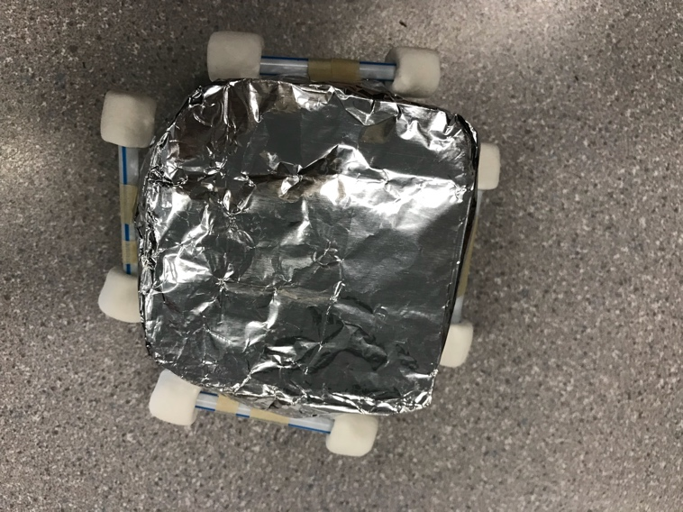
- Top view
- Bottom view
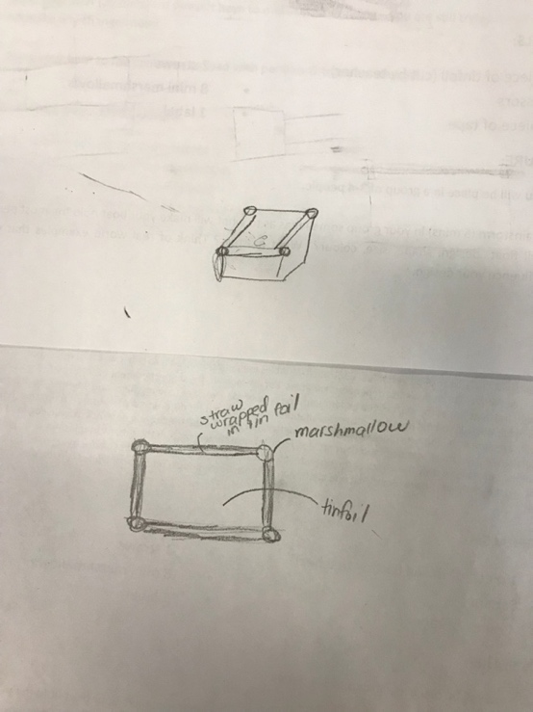
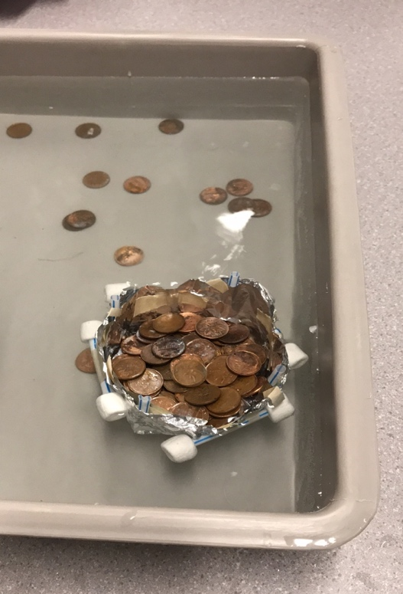
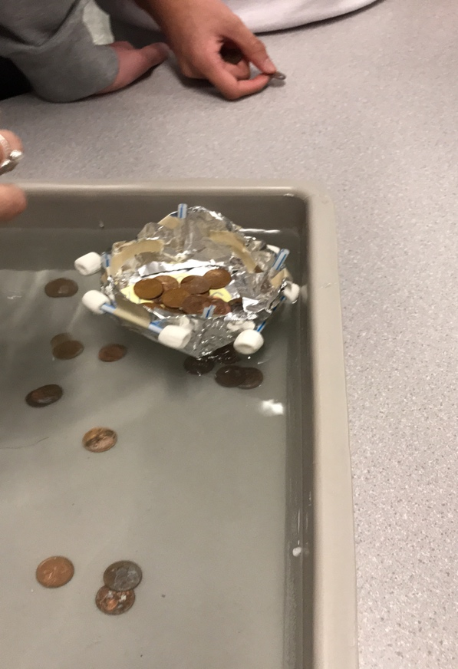
- Original design

- The H2O

Results and Conclusions:
The boat held…101

The original thinking and reasoning behind the design was…
Be compartment for pennies semi of deep and marshmallows and straws at the top so it would be more balance.

If the following challenge was repeated, to improve the boat design, the following changes would be made….because….
More even and balanced and make the foil double thick (fold it over).

