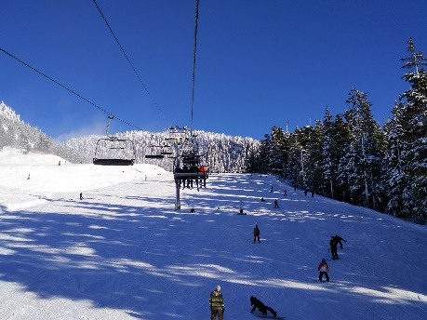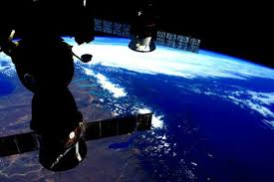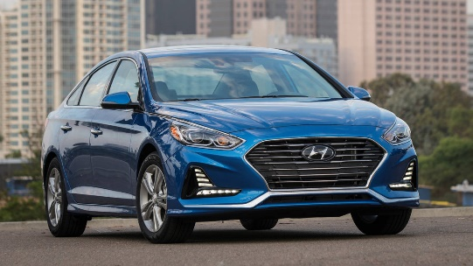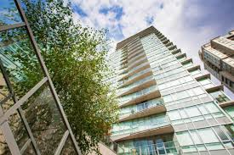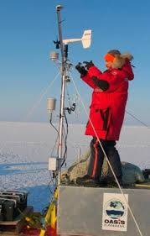

Cost of groceries / month = $400+

Cost of rent / month (1 bedroom) = $1,500 – $2,000

Cost of vehicle (Sonata 2017) = $22,800

Owning a dog (first year) = $1,270

Entertainment = $500+

Accessories (clothes, equipment, technology, extras) = $500+

Average Costs

The annual income for Atmospheric scientist start from **$50,630** to **$132,180** yearly.

Summary

This collage I done represents how I want to have regular everyday living. I would work, come home, do homework, some hobbies, leisure, relaxing or be with friends and family. I assume that I would have finished my education and started my profession, as well as gaining a vehicle to travel around the city I live in.

Future Lifestyle Collage