
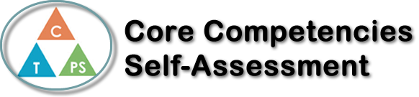
Name: Eva Kapytskaya | Date: November 2, 2017

  How does the artifact you selected demonstrate strengths & growth in the communication competency?  In what ways might you further develop your communication competency? | Self-Reflection  Describe how the artifact you selected shows your strengths & growth in specific core competencies. The prompt questions on the left - or other self-assessment activities you may have done - may guide your reflection process.  Self – Assessment – Improving Canada Project  Our unit in Social Studies 10 was focused on the Identity of Canada, and the Improving Canada Project was the final assignment for the unit. The project was to choose a topic about what we wanted to improve in Canada, then we were to conduct research, come up with 3 solutions, and then choose the best one then explain the benefits, pros and cons. This project got me to use my creative thinking and my critical thinking skills in researching a topic I was intrigued in, which was “Inflation in Canada”, I learned more about economy and how much does it effect.


How does the artifact you selected demonstrate strengths & growth in the thinking competencies?

In what ways might you further develop your thinking competencies?


How does the artifact you selected demonstrate strengths & growth in the personal & social competencies?

In what ways might you further develop your personal & social competencies?

Publish Your Self Assessment
You will now attach and/or embed your self-assessment to the bottom of the blog post with the artifact you have chosen. You may choose to make this post private or public. After placing your artifact on a blog post, follow the instructions below.
- Categories - Self-Assessment
- Tags - Now tag your post using the tag that corresponds to the competency that you have written about. You can choose more than one. Please use lower case letters and be exact.
  - #creativethinkingcc
  - #communicationcc
  - #criticalthinkingcc
  - #socialresponsibilitycc
  - #personalidentitycc
  - #personalawarenesscc
- Use the Add Document button located at the top of your post page and embed your self-assessment at the bottom of your blog post.
- Publish

