**2007 – 2008** – Leo lost his job because of a strike at the company he works at, which was bought by another company.

**2009 Sep** – Leo applied for engineering in Labrador City, NF

**2012 Sep** – I attended Castle Park Elementary for Gr.5.

**2012 Jun** – Moved to POCO to get closer to my mom’s work.

**2011** – Family went for a vacation in Cuba for the winter.

**2012 Feb** – Family moved to Richmond, BC.

**2007 Apr** – Mom applied for altar – sound technologist at Sudbury Regional Hospital.

**2007 Jan** – We moved to Sudbury, ON in Copper Cliff for my dad’s job.

**2006 Aug** – My dad applied for Mining Engineering.

**2010 Oct** – Family moved to Labrador City.

**2005 Oct** – My Dad finished his work in Ontario and moved with us.

**2005 May** – My mom and I moved to Saskatoon, SK. Neli applied for a job, while my dad was in Ontario with his work for mining engineering.

**2002 Dec 4th** – I was born in North York General Hospital in Toronto, ON.

**2002 Mar** – My mom met my dad.

**2002 Jan** – Neli entered Echo – cardiography program at Humber River College in Toronto, ON.

**2001** – Neli (my mom) came to Canada arrived from Belarus out of curiosity and wanting to start a new life.

**1988** – Leo (my dad) arrived to Canada from Ukraine to start a new life.

Ukraine Flag

Belarus Flag

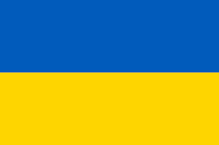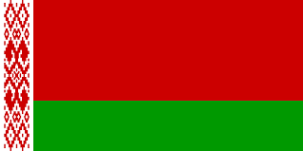

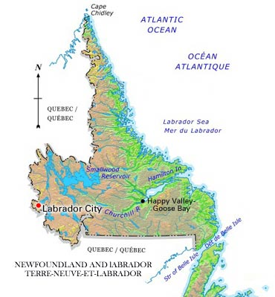Photos

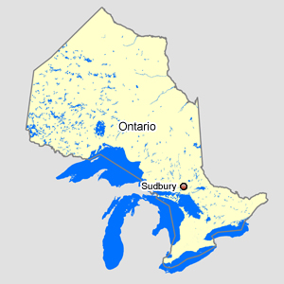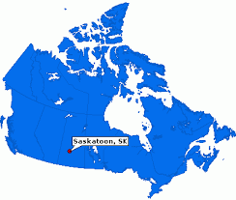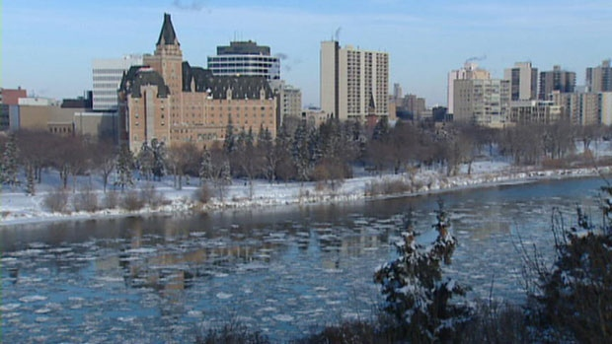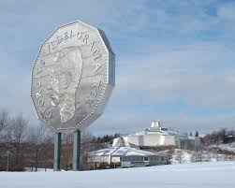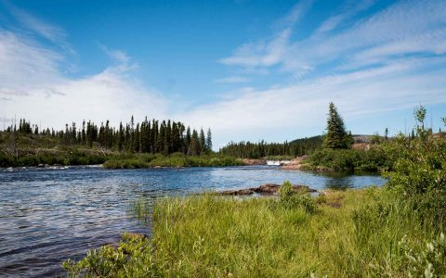

Saskatoon river in the winter.

Representing the nickname of Sudbury, the “Nickel Town” and in the back in the science center “Science North”, which is as cool as Science World in Vancouver.

I’ve taken this trail many times when I’m taking a walking down to Wabash Lake which is another part of Labrador City.