Info – Tech 10
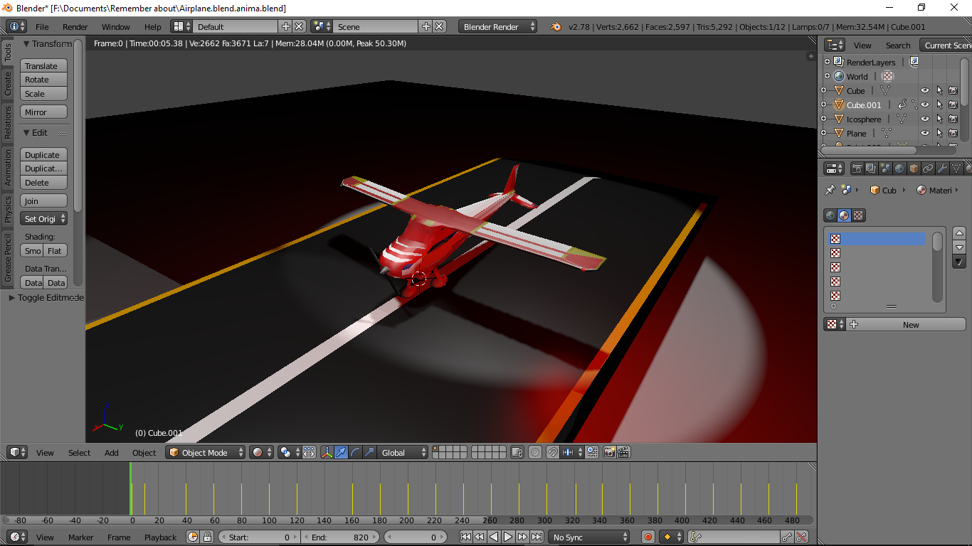
Blender – Amination

T
he first task of this project was to create a toy using Blender – an animation program which you can download for free. As you may see above, I used this program to create a toy plane, and you may be surprised that I shaped this from a single cube. Using a lot of methods like extruding, loop cut and slide, subdivide and more to make the shape, then I have to add color, and texture to make it come to life.
The second part of the project was to animate and make this plane move. It was very simple to animate, yet it was hard to make sure to position the plane correctly each time so it would flow nicely and accurate. I have also animated lights to blink like they usually do on planes and use regular lights to use as spot lights.
I
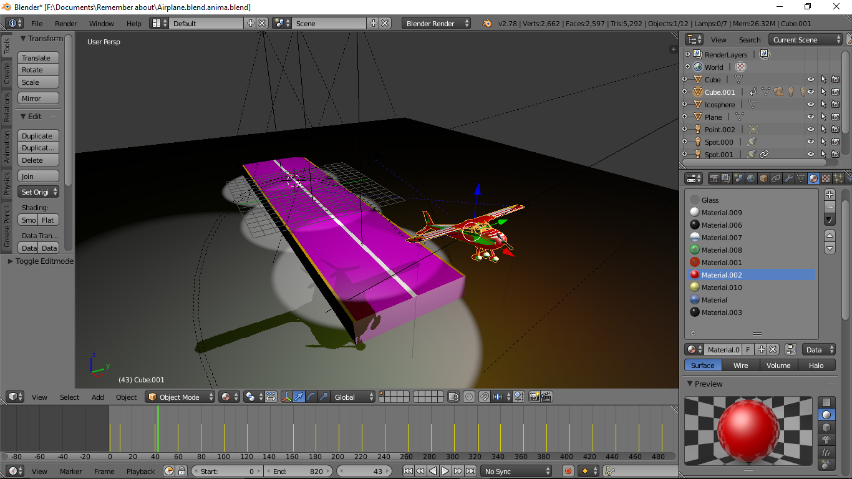
am really proud of this project, just knowing the fact that I had shaped this from a single block and not have to add any shapes (besides the wheels) and to also animate it to fly.
