s

**theguardian.**

Pg.1

DHS secretly terrorizing San Francisco

Pg.1

Editorial

Pg.1

Weather

**San Francisco News**

**DHS “TERRORIZING” SAN FRANSISCO TO FIND ANSWERS!**

Since San Fran Bay Bridge bombing, DHS took over the city seeking to catch those responsible of any convicted crimes ***by: Eva Kapytskaya***

This Issue

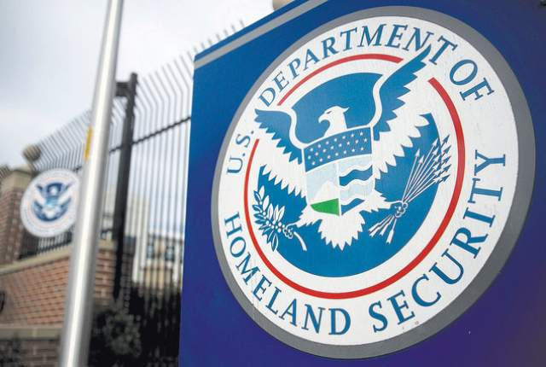

From what you have read here today the story that happened a few months ago, telling about how the DHS didn’t respect citizen rights or freedom, they were trying to protect Americans by enforcing the law stronger and arresting those of convicted crimes against the law. However, they were over doing it, by establishing the subway pay-pass cards to monitor citizens on where they’re going and then assume with there doing illegal doings in the city or not. Another example, people on the X-net planned a concert in Dolores Park to have fun and try to take back the freedom they had, but the DHS thought of it as an “illegal” gathering and decide using “special crowd control techniques” to disperse the crowd and arrest those at the concert. So my point is, since the Bay Bridge attack, the DHS was determined to find the terrorist that they thought they had the right to intrude in people’s privacy to find any evidence of crime offense. They take, interrogated and then tortured those who were thought were suspects, even though if they were innocent. To some people, they saw the DHS just doing their job, but to Marcus, he saw his freedom being taken away, so that it inspired him to stand up for what he believed in and face his problems.

It all started immediately after the worst terrorist attack that this country has ever seen, the entire Bay Bridge bombed and collapsed! Authorities have been questioning how was this possibly done. Everyone was seeking answers, especially the DHS (Department of Homeland Security) and they were determined. After the siege in the city, lots of people were missing and then later on presumed dead, however those who were missing were kept months in prison on Treasure island by who believed was the DHS. The DHS had completely taken over San Fran, committed to protect Americans, arrest those responsible of any convicted crimes, especially the terrorists. But in reality, it seemed that the authorities on DHS were willing to help, if people corporate on their terms.

Marcus Yallow is a 17 boy attending Cesar Chavez High School in the Mission District of San Fran. He admitted he goes to participate when he should be in school until he was “in the wrong place, at the wrong time”, the chaos then started, he and his friends went with the crowd until one of them, Marcus’s best friend was injured and needed attention. DHS officers investigating the scene got their need of attention and were immediately having suspensions about why a group of teens were doing so close to the crime scene. DHS officers knapped/arrested the group with force, and then taken them to a prison on Treasure Island and interrogated suspects to find answers on the Bay Bridge terrorist attack, even if the suspect were innocent, they evened used “certain techniques” to find the truth.

**by: *Eva Kapytskaya***

**Editorial**

After Marcus was kept prisoner on Treasure Island for five days, without anyone, even his loved ones knowing where he was. They released him eventually, but scared him to secrecy about the truth. When he got out, his best friend Darryl Glover was missing, no one knew what happened to him so he was later presumed dead, or so we thought. It had been months since Marcus had eventually told where he had been after the attack. During those month Marcus was secretly known as “M1k3y” on the network known as the X-net that he created, allowing people to be free online and go against the known authorizes who had taken away their rights and freedom in their country. He continued his work until he received a note from Darryl, which got him to face his problems. And Marcus’s his story finally shed some light on the DHS. Marcus was then captured by the DHS again and then tortured him for his passwords on a network known as the X-net. Barbra Stratford is one of the investigative reporters at the Guardian to published Marcus’s story for America to see. She and a squad of California State troopers arrested the director of the DHS, Carrie Johnstone and given all of the prisoners on the island a chance to prove their innocents in a proper trial.

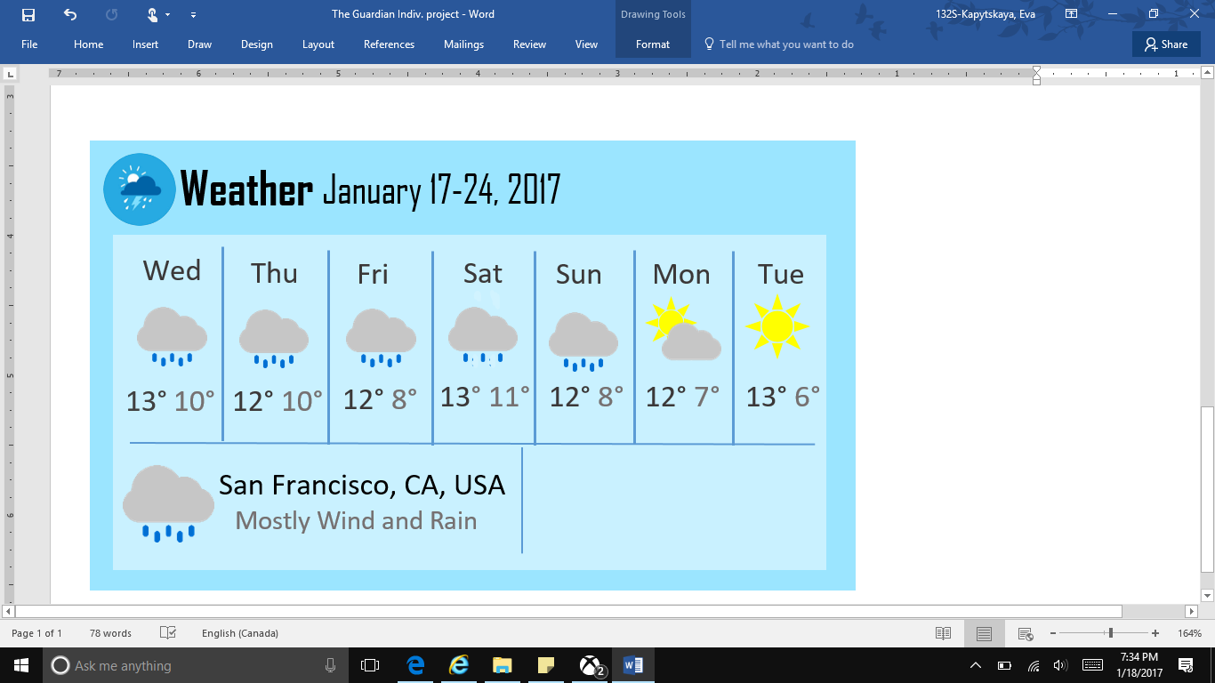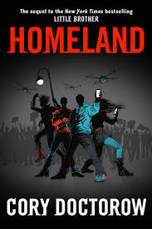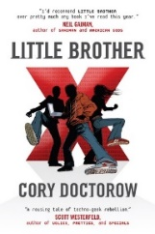

Psst! Hey, wanna learn more about Marcus and his story.

Check out LITTLE BROTHER and the sequel HOMELAND by Cory Doctorow! 🡺