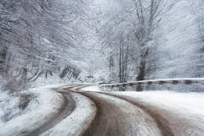
“But the rivers, levelled with ice and snow, were the winter highways of the mountains".
- Metaphor

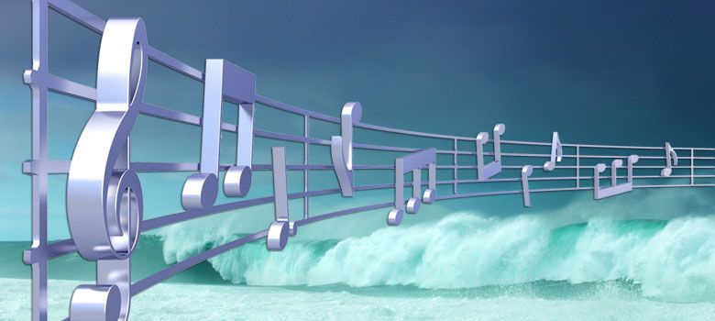
"the loud wind howling in crescendo by his ears."
- Personification

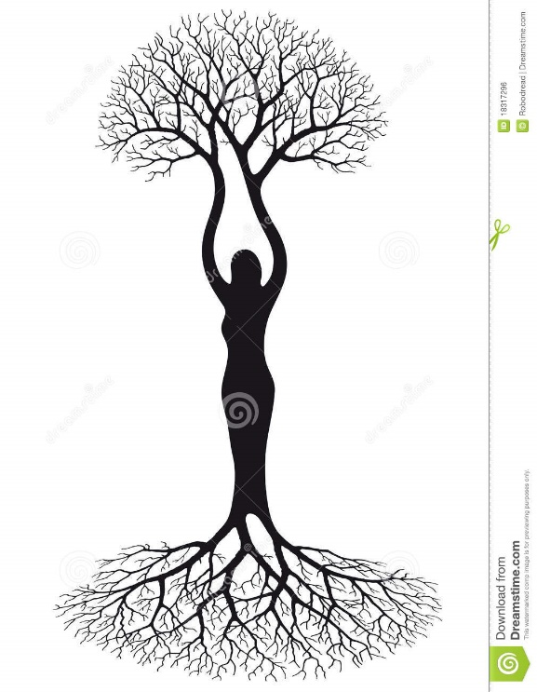
That tree, like a strong and' lonely woman, called to his
wary body to stop.
- Simile

"the sun westering behind the ranges threw long feeble shadows across the snow".
- Personification

