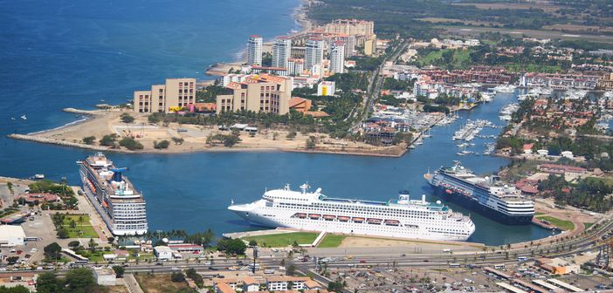
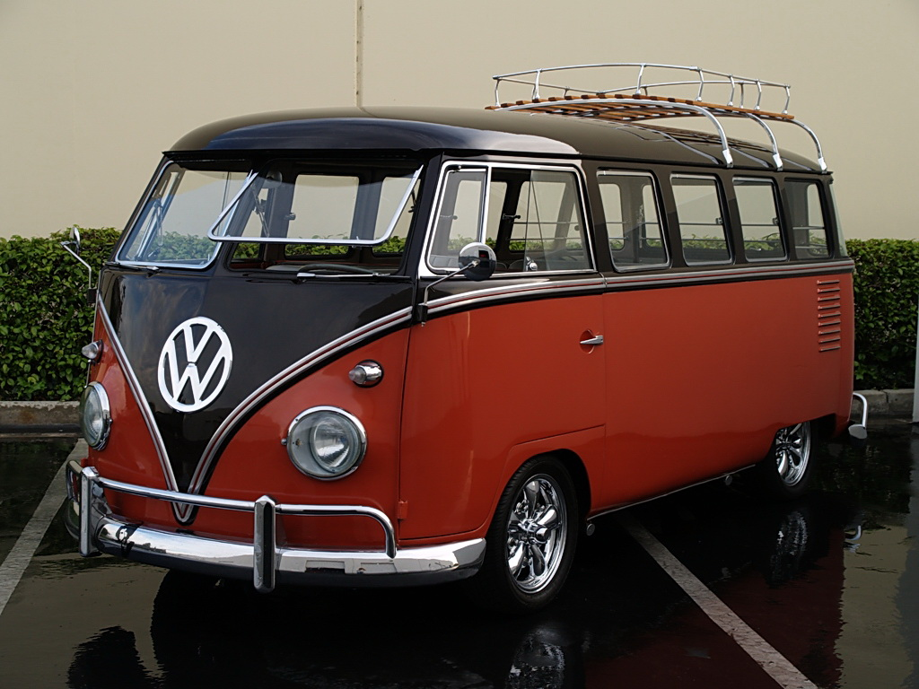

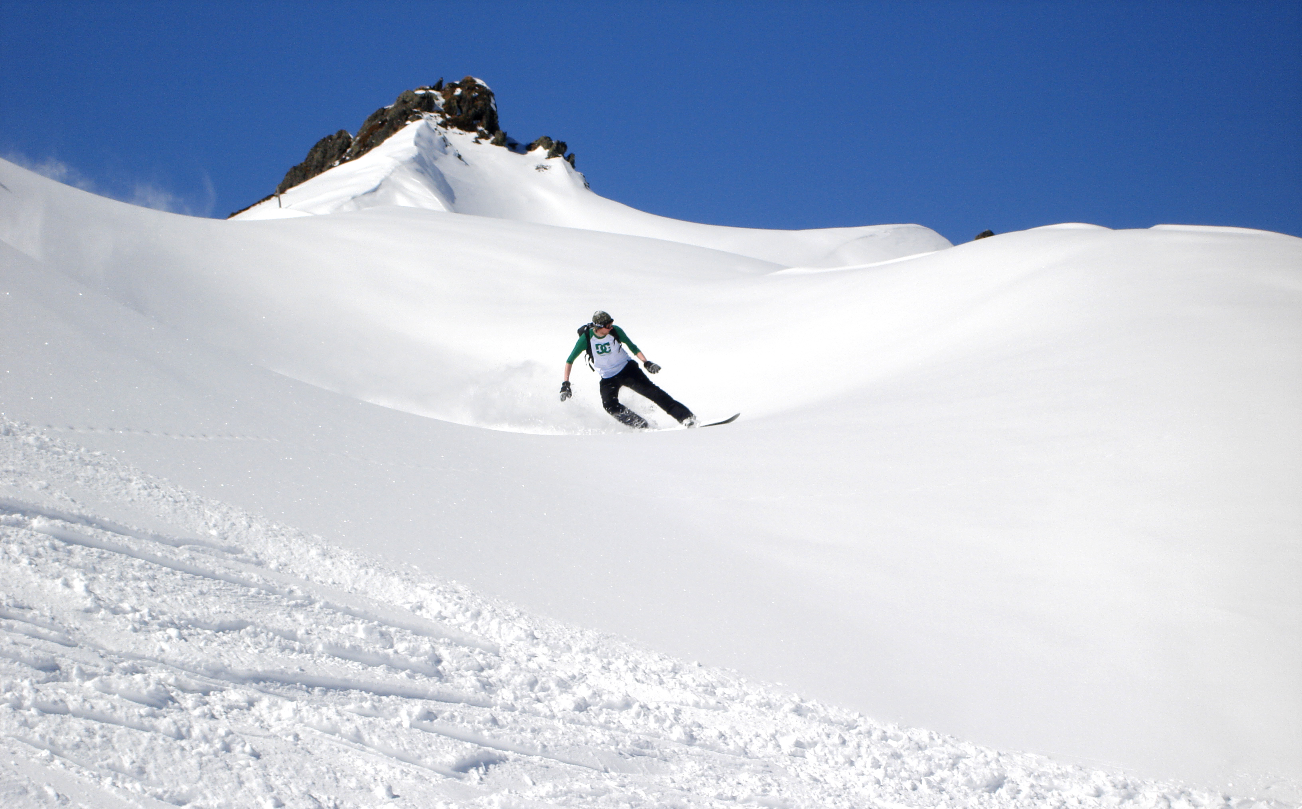
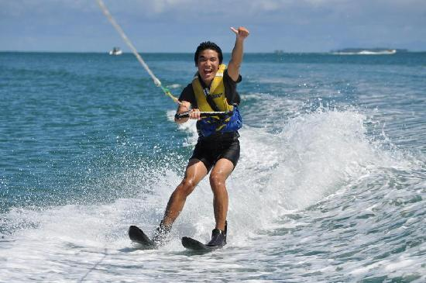
I wake up and have a cup of coffee and look out at the beach and have breakfast. Then I get ready to drive out to my NHL hockey game in Seattle ( Seattle is going to get a expansion team soon so I just put the Canucks to represent playing in the NHL). I get to the arena and get ready to warm up after warmup I get dressed and go out to play the game. After the game I go out for dinner with my family and come home and watch Netflix and go to bed. On a off day I would either go waterskiing or go to one of the mountains and snowboard and in the offseason take a trip down to Puerto Vallarta.

My annual income for a hockey player is 1.6 million per year minimum

Car = 15 000$
House = 3.2 million $
Pug = 1200$
Trip to Puerto Vallarta = 544$
Wedding = 22 079$
Boat = 18 000$
Water skis = 160$
Snowboard = 120$
Raising kids = 233 610$ up to 17 years old

