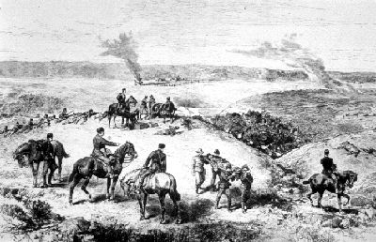

Thompson Sherle
Westminster Ave. 2477
London, England
Mar 4, 1890
Dear Father,
During my time in Canada I’ve seen and done a lot of things, but over these past couple years so much has happened. Firstly, the Metis who lived here in Manitoba moved to Southern Saskatchewan to live. But over time more and more settlers came to settle in the west and settled where the Metis were. Then in 1884 a group of four delegates including Gabriel Dumont talked to Riel and did convince him to come back and help with their resistance. Then after a few months of living with many different groups of Metis, he decided to send a petition to Ottawa which included the concerns of the Metis, Indian people and the settlers. Prime Minister Macdonald ignored the petition and at Duck Lake the first battle of the north-west resistance started. But in the end General Middleton’s militia won the battle at Batoche and a couple days later, Pound maker (An Indian chief) surrendered and was sent to prison and Big Bear (another Indian chief) was chased by Middleton and was eventually arrested and sent to prison. After the resistance Riel was tried and sentenced the death by hanging. Long story short, Quebec was upset because Riel was half French being Metis. Our family has been doing quite well. We’ve had another child and his name is Patrick. Patrick has just turned 9 while Albert is 19 and now has a job with the North West Mounted Police. Our farmland has been making a steady profit for us. So with Albert’s profit from the NWMP we ar4e managing nicely. Will write again soon.
From
Ethan
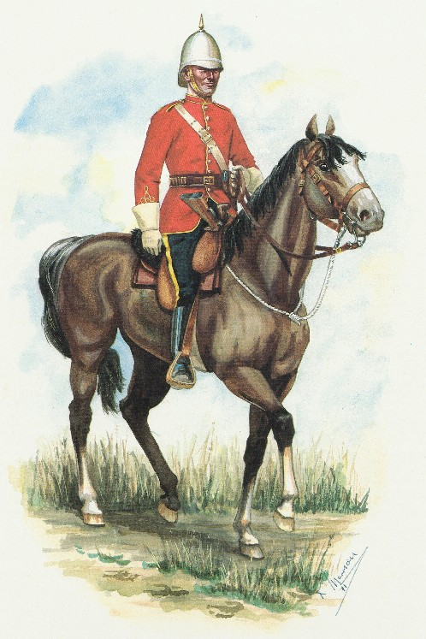
David Sherle
5802 Windsor St.
Oxford, England
Dec 24, 1896
Dear Brother
Today should be a day of celebration. A day were everyone comes together as family to one another. But one piece of that family is missing. I thank you for telling me about dad’s passing, I still want to keep in touch with the rest of the family so I will continue to write to you and I ask you to tell everyone else. Well here’s some news about what is happening over here. Our new Prime Minister Sir Wilfred Laurier was just elected. He is a Frenchman so I don’t trust him nor do I like him either. Also, there was a huge schooling problem here in Manitoba. The Canadian government wanted to create two school systems, one French Roman Catholic and one English. There were lots of agreements but last year the conservatives were going to pass a bill that would give back the rights of the French Canadians. But right before that, the election happened and the liberal party won. We still don’t know if the bill will pass but our family hopes it does happen so the English family can send their kids to a good school. In other news Sarah is doing just fine. Patrick is finishing up his schooling and is planning on going to university. Albert is still working with the NWMP and I may be getting brittle in my old age but I don’t feel a day over 35. I will write to you soon. Happy Christmas!
From
Ethan

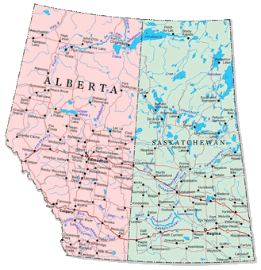

David Sherle
5802 Windsor St.
Oxford England
Jan 3, 1906
Dear Brother
Life seems to be passing me by. My old bones and muscles don’t work like in my young age. I came here when I was 20 years old, I grew with this country and I will be laid to rest here in the arms of my country and will rise to the heaven to see old friends and family and to watch over my kids and their kids. It’s might be my last letter to you brother. Don’t feel sad by this because we will be reunited soon. Laurier has appointed Clifford Sifton to be minister of immigration and he’s brought in thousands of new immigrants. New people from eastern Europe and some from Asia. We also have two new provinces added to Canada. These new provinces are Alberta and Saskatchewan and they have a lot of prairie land and new farm land to take. Albert and Patrick have come home to help me and my dearest Sarah through our final days on this earth. One last goodbye from me to you brother
From
Ethan

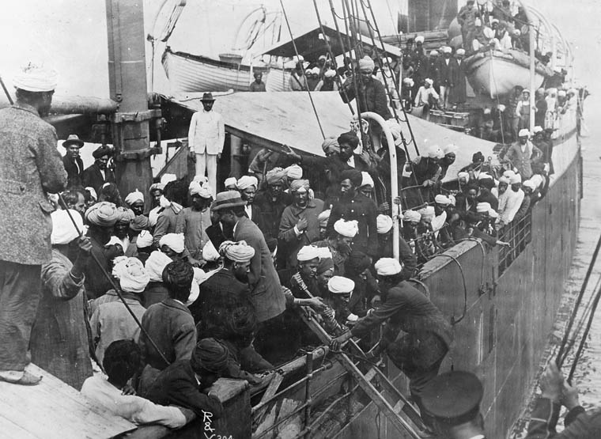

Al Sherle
Dove Cres.
Oxford England
Aug 28, 1916
Dear Cousin Al
Hello, its Patrick writing, I know we haven’t formally met before but as you are aware, staying in touch with each other and talking about our lives was our father’s final wishes. So, let me tell you what has happened over this last couple years here in Canada. Firstly, after mother and father past away. Albert and I moved to Red Deer, Alberta to purchase land to live on and raise our families. Then in came the Continuous Voyage act that said any immigrant ship coming to Canada could not stop to refuel and restock. But then in 1914 a ship called the Komagata Maru was carrying 354 Sikh people (People from India). The ship did stop to refuel so when it got to Canada it was quarantined and many people starved to death. I don’t agree with the Canadian government decision and I feel they should apologize. Now that Canada has a lot of Chinamen who have taken over the jobs they are starting to close immigration with Asian countries. As you can see there is a lot of rascal discrimination in Canada and I’m starting to wonder if this will ever end. I’ll write you back when times are better.
From
Patrick

Cites
Clark, P., & MacKay, R. (1993). Canada revisited: a social and political history of Canada to 1911. Edmonton: Arnold.

