Barney 1

Exposition: "we are alone on the island now, barney and I" (page 211)

Rising Action (conflict): "The pretty vandalisms I could have forgiven, but when he tried to poison barney out of simple malice, he was standing in the way of scientific progress." (page 211)
Rising Action: "After only 2 weeks of glutamic acid treatments he has become more interested in my library, dragging the books from the shelves and going over them page by page" (page 212)

Rising Action: "After a quick survey of the room he returned to his cage, sprang upon the door handle, removed the key with his teeth and before I could stop him he was out the window" (page 212)

Rising Action: " By the time I reached the yard I spied on him on the coping of the well, I arrived on the spot only in time to hear the key splash into the water" (page 212)

Climax: "A few feet from the top I heard exciting squeaks from barney, and upon obtaining ground level I observed that the rope was almost completely severed”

Falling Action: "perhaps I should fix myself a sandwich as I may be down there longer than it seems at the moment"

Resolution: "Do not look for my body as I will cast myself into the see you mite bring a couple of young rats as a living memorial to barney females- no males"

2
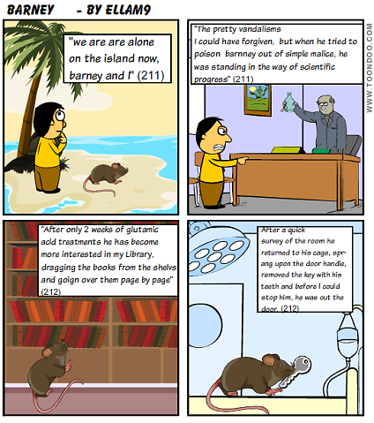

3
