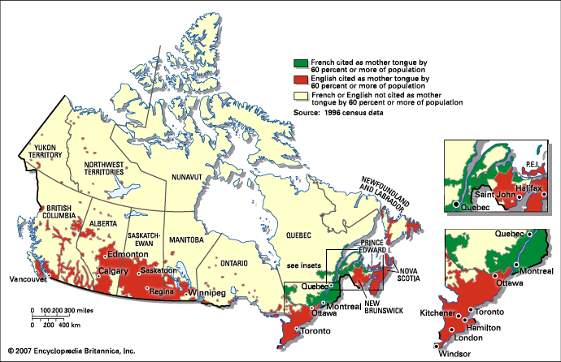
This is Canadian map. And Canadian have speak France and English.
Canada is a country located in the northern part of North America. Its's ten provinces and three territories extend from the Atlantic to the Paclific and northward into the Arctic Ocean, covering 9.98 million square kilometres. It is highly urbanized with 82 percent of the 35.15 million people concentrared in large and medium-sized cities, many near the southern border. It's capital is Ottawa, and its three largest metroplitan areas are Toronto, Montreal, and Vancouver.
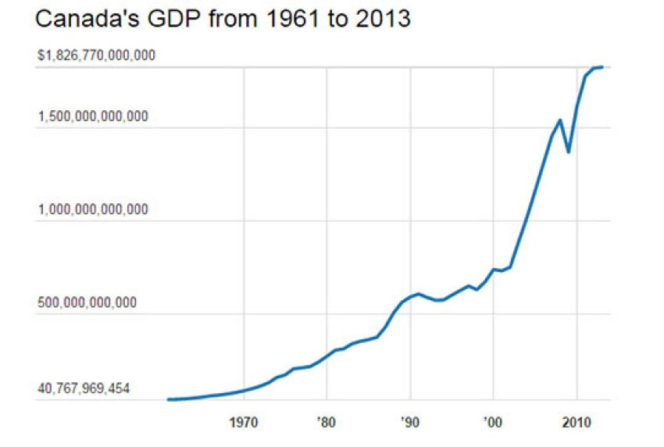
Canada is a developed country and has the fifteenth-highest nominal per capita income globally as well as the tenth-highest ranking in the Human Development index.

