Float Your Boat Challenge
By: Dylan
Group Members: Emma Hudson, Jared Las
Science 10 Block d

Problem: To make a boat float and hold as many pennies as possible with selective buoyant materials.

Hypothesis: If the buoyancy due to the marshmallows is spread around equally under the boat, then the boat will hold the most amount, because it will be the most balanced.

Observations:
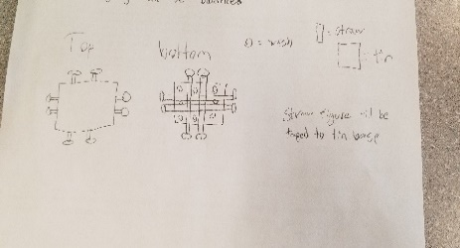
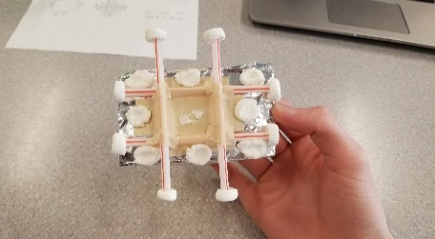
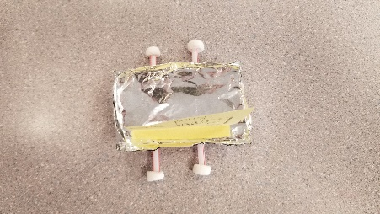
Tape
Straw used for base
S.S. Emma Khud Sign
Tin Foil
Marshmallow
Top View Bottom View Original Design

Results and Conclusions:
The boat held 19 pennies.

The original thinking and reasoning behind the design was that by making a tic-tac-toe shaped base, the weight would be spread more evenly. As well, by folding the tin foil in half the weight would be denser.

If the following challenge was repeated, to improve the boat design, the following changes would be made… no folding of the tinfoil and level base rather than stacked, because it would be more balanced in the water relative to the uneven placement of the pennies, and would allow for more room and harder to reach top.

